 | National Institute of Plant Health Management  Department of Agriculture & Cooperation  Ministry of Agriculture  Government of India | 
Telephone: 9140-24015374  E-mail: niphm@nic .in  Tele-Fax: 9140-24015346 |  | Rajendra Nagar,  Hyderabad – 500 030  http://.niphm.gov.in
F. No. 4(2)/Furniture/NIPHM/NFB/2012-13/48 Dated: 03.03.2014

To

*(The tender document is also being uploaded on the NIPHM website http://niphm.gov.in and the other prospective bidders can make use of the document down loaded from the website)

Sub: - Limited Tender for Procurement of "Office Furniture for Computer Labs of
NIPHM” (retender)– reg.
* * *
Sir/Madam,

National Institute of Plant Health Management (NIPHM) invites ‘Sealed Bids’ under ‘two cover systems’ from the reputed manufacturers/distributors/authorized dealer/agents for procurement of Office Furniture for Computer Labs of NIPHM. Detailed terms and conditions and list of items required may be downloaded from the NIPHM website http://niphm.gov.in

The schedule of receipt and opening of quotations is as under:-

Last date and time for receipt of bids :: 14:00 hrs on
20th March, 2014.

Date & Time for opening of bids :: 15:00 hrs on
20th March, 2014.

Registrar I/c

National Institute of Plant Health Management
Department of Agriculture & Cooperation
Ministry of Agriculture
Government of India
Telephone: 9140-24015374  E-mail: niphm@nic.in  Tele-Fax: 9140-24015346 |  | Rajendra Nagar,  Hyderabad – 500 030  http://niphm.gov.in

TENDER DOCUMENT

FOR

PROCUREMENT OF OFFICE FURNITURE
FOR COMPUTER LABS OF NIPHM (RETENDER)

Note:
- The bidders are requested to sign on all the pages.
- This tender document can be downloaded from website – http://niphm.gov.in
- The tender document is to be put in a cover which should also be sealed & superscribed “TENDER FOR PROCUREMENT OF OFFICE FURNITURE FOR COMPUTER LABS OF NIPHM”

TABLE OF CONTENTS

Sl. No. | Description | Page No
1 | Preamble of Tender | 3
2 | Check List | 4
3 | Salient Features of the Tender | 5
4 | General Instructions | 6
5 | Eligibility Criteria | 7
6. | Scope of work, Terms of Supply and Price Bid Validity | 7-8
7 | Submission of Tender | 8-9
8 | Opening of Tenders | 10
9 | Tender Evaluation Criteria | 10
10 | Acceptance of Tender | 11
11 | Rejection of Tender | 11
12 | Payment of Security Deposit | 11
13 | Terms of Payment | 11
14 | Details of Bidder’s Profile/Part ‘A | 12
15 | Technical specification– Annexure II | 13-14
16 | Details of Price Bid/Part ‘B’ – Annexure – III | 15
17 | Format for Authorisation letter – Annexure –IV  Format of Under taking – Annexure - V | 16  17

Preamble of Tender

National Institute of Plant Health Management, an autonomous Institute under Ministry of Agriculture, Govt. of India is mandated to promote environmentally sustainable Plant Health Management Practices in diverse and changing agro-climatic conditions and provide policy support to Central and State Government on Plant Health Management, Sanitary and Phyto-sanitary issues and emerging bio-security challenges.

The computer laboratories of the Institute needs to be furnished with furniture to carry out the training research activities of NIPHM. NIPHM invites ‘Sealed Bids’ under ‘two cover system’ from the reputed manufacturers/distributors/authorized dealer/agents for procurement of office furniture and laboratory furniture as enclosed at Annexure II.
2. CHECK LIST

BIDDER TO FILL IN THE CHECK LIST GIVEN BELOW

(State YES/NO for each item)
Sl. No. | Details | YES/NO
1. | Whether the Technical Bid (envelope A) and Price Bid (envelop B) are submitted in separate covers and both the covers enclosed in a common envelop.
2. | Whether Technical Bid (Envelope A) contains:
 | - Pre-Qualification details as laid down in the Tender under Eligibility Criteria.
 | - Technical Bid in the original Tender document and other supportive documents including leaflets/pamphlets.
 | - Filled up and signed Technical Specification statement viz., Annexure I
 | - Technical specification statement –Annexure - II
 | - Letter of Authorization for signing the Tender document viz., Annexure IV & Under taking as per Annexure V
 | - Audited Annual reports
3 | Whether Envelope-B contains:  Filled up and signed Price Bid documents, viz., Annexure III

NOTE: Please ensure all the relevant boxes are marked YES/NO against each column.

IMPORTANT NOTE: Bidders must ensure that all the required documents indicated in the Tender documents are submitted without fail. Tenders received without supporting documents for the various requirements mentioned in the tender document are liable to be rejected at the initial stage itself.

3) SALIENT FEATURES OF THE TENDER
Tender For Supply of Office Furniture for Computer Labs of NIPHM
1 | Tender inviting Authority , Designation and Address | The Registrar,  National Institute of Plant Health Management,  Rajendranagar  HYDERABAD – 500 030. A.P.  Phone No. 24015346/043/374  Telefax No. 24015346  Email : niphm@nic.in ; registrarniphm@nic.in  Website : http://niphm.gov.in
2 | a)Name of the Work | Supply of Office Furniture for computer Labs
2 | b)Tender reference | F.No. 4(2)/Furniture/NIPHM/NFB/2012-13/
2 | c)Place of contract | NIPHM, Rajendranagar, Hyderabad – 500 030. A.P.
2 | d) Contract Period/validity period of Bids | Bid prices shall remain valid for the period of 90 days after the last date for bid submission. However, the purchaser reserves the right to seek consent for an extension of the period of validity. A bid valid for a shorter period shall be rejected by the Purchaser as non-responsive.  And the Purchaser reserves the right to increase/decrease the quantity of goods, originally specified in the Schedule of Requirements.
3 | Availability of  Tender documents | Tender documents can be downloaded from http://niphm.gov.in at free of cost.
4 | Earnest Money Deposit (EMD) | Bidders are exempted from Earnest Money Deposit.
5 | Due Date, Time and Place of Submission of Tender | Up to 1400 hrs on 20.03.2014 at the address mentioned in (1)
6 | Date, Time and Place of Opening of Bidder’s Profile-A | On 20.03.2014 at 1500 hrs at the address mentioned in (1)
7 | Other important criteria specified by the Tender Inviting Authority:  - Eligibility Criteria:  - The firm should have at least 3 years similar work experience as on 31.10.2013.  - The Annual Gross turnover of the manufacturer should be Rs.25.00 lakhs & for other bidders Rs.20.00 lakhs at least for one year during last three years.  - The firm should be registered under Income Tax Act.  - The firm should be registered under VAT.

4. GENERAL INSTRUCTIONS :

4.1 The Bidders are requested to examine the instructions, terms & conditions and specifications given in the Tender. Failure to furnish requisite information in all respects may result in rejection of the bid. Tenders received after due date and time shall be rejected.

  - Clarifications in the Tender

- A prospective Bidder requiring any clarification regarding the Tender may address the Tender Inviting Authority by letter or by Fax upto 48 hrs prior to the last date. NIPHM will respond in writing to any request for clarification in the Tender.
- The responses to the clarifications will also be notified on NIPHM’s website http://niphm.gov.in

4.3 Amendments to the Tender

- NIPHM may amend the Tender Conditions up to 2 days prior to the time fixed for receipt of the Tender.
- Amendment to the tender, in response to clarifications sought by prospective Bidders, is solely at the discretion of NIPHM. Such amendments will be notified on NIPHM’s website.
- NIPHM, at its discretion, may or may not extend the due date and time for the submission of bids on account of amendments. Extension of time will be notified on NIPHM’s website.
- All the Bidders are advised to periodically browse NIPHM website http://niphm.gov.in for any amendments or corrigenda issued in connection with this Tender. NIPHM will not be responsible for any misinterpretation of the provisions of this tender document on account of the Bidders’ failure to update the bid documents based on changes announced through the website.

4.4 The tender should be addressed to

The Registrar,
National Institute of Plant Health Management,
Rajendranagar, HYDERABAD – 500 030. A.P.
Phone No. 24015346/043/374 Tele Fax No. 24015346
Email : niphm@nic.in ; registrarniphm@nic.in ;
Website : http://niphm.gov.in

4.4 Any offer made in response to this tender when accepted by NIPHM will constitute a contract between the parties.

4.5 The supplier shall not be entitled to any increase in the rates

4.6 The agency shall not transfer or assign sub-contract to any other party.

4.7 Corrections, if any, must be attested. All amounts shall be indicated both in words as well as in figures. Where there is difference between the amount quoted in words and figures, amount quoted in words shall prevail.

4.8 The Price should be quoted only in Indian Rupees.

4.9 The bidder shall also provide CST certificate in case the bidder claims CST.

4.10 Corrupt or Fraudulent Practices: Bidders should observe the highest standard of ethics during the procurement and execution of such contracts.

“Corrupt practice” means the offering, giving, receiving or soliciting of anything of value to influence the action of public official in the procurement process or in contract execution, and

“Fraudulent practice” means a misrepresentation of facts in order to influence a procurement process or the execution of a contract to the detriment of the Purchaser and includes collusive practice among Bidders (prior to or after bid submission) designed to establish bid prices at artificial non-competitive levels and to deprive the Purchaser of the benefits of free and open competition.

NIPHM will reject a proposal for award if it is found that the Bidder recommended for award has engaged in corrupt or fraudulent practices in competing for the contract in question.
5) ELIGIBILITY CRITERIA:-

The Bidders should meet the following Eligibility Criteria for quoting the tender and the proof for the Eligibility should be provided in the Technical Bid.
Sl. No | Minimum Eligibility Criteria | Proof to be submitted for fulfilling the Eligibility | Page No. (s)
1 | The Bidder shall be a manufacturer of the furniture or an Authorized Dealer/Agent | Registration Certificate of the Company or Dealer/Agent Certificate
2 | The firm should have at least 3 years experience in dealing/supplying such furniture as on 31.10.2013. | Documents to prove that the company/firm has supplied such furniture in their business for 3 years.
3 | In respect of manufacturers gross annual turnover of Rs. 25 lakhs at least for one year during last three years  In respect of authorized dealer, the turnover of the manufacturer will be taken into account.  In respect of other bidders the annual gross turnover should be at least Rs. 20.00 lakhs (Rupees Twenty Lakhs only) at least for one year during last three years  Turnover not applicable to registered suppliers with NIPHM/DGS&D/CRIDA-ICAR Units | Copy of Annual Accounts duly signed and attested by a Chartered accountant.
4 | The firm should be income tax assessee at least for a period of three years. | Self attested copies of the acknowledgments of Income tax returns and PAN Card of the firm should be enclosed.
5 | The firm should be registered under VAT. | Self attested copy of the certificate.
6. | In case a bidder bids on behalf of more than one Manufacturer for different furniture, he should be a Authorized Dealer/Agent for those manufacturers. | Dealership/Agent Certificate from each manufacturer.
7. | Earnest Money Deposit | Bidders are exempted from Earnest Money Deposit.

6. SCOPE OF THE WORK:-

- To supply quality products which substantially match the specifications laid down by NIPHM. The specifications of Office furniture offered shall be mentioned in the comparative statement vide Annexure – II.

- The Bidder should provide Warranty for a minimum period of 3 (three) years for products quoted. For defects noticed during the Warranty period, replacement/rectification should be arranged free of cost within a month.

- The furniture to be supplied should be of standard quality and termite free.

- Director General, NIPHM reserves the right to reject any or all the quotations received without assigning any reason whatsoever.

6.1 Terms of Supply:

The firm should supply the items within 30 days from the date of purchase order.

6.2 Price Bid Validity:

Bids shall remain valid for a period of 90 days after the last date for bid submission. However, the purchaser reserves the right to seek consent for an extension of the period of validity.

6.3 RATES AND PRICES

- Bidders should quote the rates in the format given Price Bid - Annexure – III A, B & C. Incomplete bids will summarily be rejected. All corrections and alterations in the entries of tender papers will be signed in full by the Bidder with date. No erasing or over writings are permissible. Price quoted shall be firm and final.

- Prices quoted should be for FREE DELIVERY at NIPHM, Hyderabad-500 030.
- The percentage of sales tax/VAT, surcharge, if applicable and other levies legally leviable and intended to be claimed should be clearly indicated in the tender. Where this is not done, no claim on these accounts would be admissible later.

- Sales tax /VAT should be indicated clearly.

7. SUBMISSION OF TENDER:-

Submission of Tender: Two-cover system will be followed:

7.1 General Instructions:

- The Tender proposes two stage tender systems viz. (1) Technical Bid and (2) Price Bid.
- The bids should be submitted in two envelopes viz.
Envelope-A: Bidder Profile / PART – A (Annexure I)
Envelope-B: Price Bid/Price Bids / PART – B (Annexure III – A, B, &C)

- Both the covers must be sealed separately and super scribed with Tender number, due date and Name of the Envelope on the respective covers. These two covers should be enclosed in a separate cover and addressed to the Inviting Authority i.e., Registrar, NIPHM, Rajendranagar, Hyderabad – 500 030.

  - Details to be furnished in the Envelope-A Technical Bid:

- Profile of the Company – stating whether the firm is partnership/registered under the Companies Act along with its necessary enclosures

- Technical specification statement – Annexure II.

- Authorization letter and undertaking (as per Annexures IV and Annexure V) from the Competent Authority of the Company to sign this Tender document. Documents received without such authorization will not be considered for further processing. This is not applicable if the proprietor signs himself as competent authority.

- The Bidders should furnish the location with addresses and license details of the firm.

- The Bidders shall furnish as part of the bid, documents establishing the Bidders eligibility to bid and its qualifications to perform the Contract if their tender is accepted.

The documentary evidence of the Bidder's qualifications shall be established to the satisfaction of NIPHM. However, the decision of Director General, NIPHM will be final in this regard.

  - Signing of Bids

Individual signing the tender or other documents connected with contract must
specify whether he signs as:

i) A “Sole proprietor” of the concern or constituted attorney of such sole proprietor;

ii)A partner of the firm, if it is a partnership firm in which case he must have authority to execute on behalf of the firm.

iii)Director or a Principal Officer duly authorized by the Board of Directors of the
Company, if it is a Company.

- The bids shall be typed or written in indelible ink and shall be signed by the Bidder or a person or persons duly authorised to bind the Bidder to the Contract. Bidders are requested to sign each and every page of the tender document including Annexure(s) attached thereto.

- Any alterations, erasures shall be treated valid only if they are authenticated by full signature by the person or persons authorised to sign the bid. Tender documents should be free from over writing.

  - Details to be furnished in the Envelope-B i.e., Price Bid

Prices must be quoted only in the Price Bid Form (Please see the “PART-B- PRICE BID – ANNEXURE III”.

  - Mode of Submission:

- Both the Envelopes viz. Envelope-A and Envelope-B must be put in a single cover, sealed and must be super scribed “Tender for supply of Office Furniture for Computer Labs of NIPHM. It shall be addressed to The Registrar, National Institute of Plant Health Management, Rajendranagar, Hyderabad – 500 030. A.P.

- The Tender may be dropped in the Tender box kept at NIPHM office.

- Alternatively, the Tenders must reach NIPHM on or before the due date and time by registered post/courier. NIPHM will not be liable or responsible for Postal/Courier delay, if any.

- The Tenders received after Due Date and Time or Unsealed or incomplete shape or Tenders submitted by Facsimiles (FAX) or by Electronic mail will be summarily rejected.

- A Tender once submitted shall not be permitted to be altered or amended.

7.6 Service of Notice:

Any notice hereunder may be served on the Successful Bidder by Registered Post at his last known address. Proof of issue of any such notice should be conclusive of the Successful Bidder having been duly informed.

8. OPENING OF TENDERS

  - Tender Opening:

- Tenders will be opened at the prescribed date and time in the presence of Bidders or their representatives who choose to be present. The representatives of Bidders must bring the authorization letter from the bidding companies for attending the Tender opening. Not more than two representatives for each Bidder would be allowed to take part during the bid opening process.

- Envelope-A containing Technical Bid would be opened first. Eligibility Criteria such as pre-qualification conditions will be checked and the supporting documents would be cross checked wherever required.

- Only the Technical Bid will be opened on the due date.

- The date, time and venue of opening the Price Bid will be intimated separately. The price bids will be opened at the appointed time in the presence of bidders who choose to be present.

- Tenders non compliant with any of the tender terms will not be considered for the next stage i.e. for opening of the Price Bid.

9. TENDER EVALUATION CRITERIA:
The evaluation of Tenders will be done by NIPHM as detailed below:

9.1. Technical Bid evaluation:

Bidders will be eligible for further processing only if they fulfill the following criteria
- Compliance with the eligibility Criteria.
- Compliance with Technical and capacity requirements.
- The literature/pamphlets with specifications of the equipment quoted should be supplied along with the technical bid.
- A table comparing the NIPHM specification and with that of the firm’s specification and remarks as per the enclosed annexure-II.

NIPHM will prepare a list of Bidders whose bids are substantially responsive with the technical and capacity requirements as given in Tender form. The Bidders who do not match eligibility criteria or which do not conform to the Technical Specifications shall be rejected. The Eligible Bidders alone will be considered for further evaluation.

9.2 PRICE BID EVALUATION:

Opening of Envelope-B Price Bid:
Bidders who are qualified in Technical Bid (Envelope-A) only will be called for Price Bid opening. The technically qualified Bidders alone will be informed about the date and time of opening of the Price Bid and their Price Bids alone will be opened on the due date and time in the presence of the Bidders or their authorized representatives who choose to be present. The contract will be entrusted to the Bidder, whose bid has been determined as L1. L1 will be arrived after considering basis price, taxes and other charges, if any. As items are different, L1 will be arrived for each item separately. In case the L1 agency who has been awarded the tender fails to execute the contract, NIPHM will have the right to choose L2 and shall recover the excess cost from L1 as penalty for backing out after award of contract. NIPHM further reserves the right to take legal action to get such firms black listed.

10. ACCEPTANCE OF TENDER

- The final acceptance of the Tender is entirely vested with NIPHM which reserves the right to accept or reject any or all of the Tenders in full or in part.

- After acceptance of the Tender by NIPHM, the Bidder shall have no right to withdraw his Tender and Prices payable to the Supplier as stated in the Contract shall be firm and not subject to any adjustment during performance of the Contract.

- The Tender accepting authority may also reject all the Tenders for reasons such as changes in the scope of work, lack of anticipated financial resources, court orders, accidents or calamities and other unforeseen circumstances.

- After acceptance of the Tender, NIPHM would issue Letter of Acceptance (LOA)/award the purchase order only to the Successful Bidder. NIPHM also reserve the right to issue Purchase Orders to more than one Bidder under rate contract. The letter of acceptance will include the details along with terms and conditions of the tender.

11. Rejection of Tender:

NIPHM also reserves the right to reject/cancel the tender without assigning any reason thereof.

12. PAYMENT OF SECURITY DEPOSIT (SD):

- The Successful firm(s) shall require to deposit 10% of the order value as Security deposit/Performance Security either by means of demand draft or irrevocable Bank Guarantee obtained from any nationalized/commercial banks in favour of National Institute of Plant Health Management (NIPHM), the Hyderabad which should be valid beyond 60 days beyond the date of completion of all contractual obligations of the supplier including warranty obligation. The security deposit will be released/discharged after 60 days of completion all contractual obligations of the supplier including warranty obligation

13. Terms of Payment:

Payment will be released within 15 days after supply of the furniture and issue of final certificate by the officer to that effect.

The Supplier/firm should submit the invoice in triplicate. The invoice should contain the Sales tax/VAT registration number and there should not be any overwriting/cuttings/corrections. An advance stamped receipt should be enclosed along with invoice.

******
Annexure I

14. Bidder’s Profile- PART-A:-

SUPPLY OF OFFICE FURNITURE & LABORATORY FURNITURE:

    - THE FIRM
- Name
- Regd. Address
- Address for correspondence
- Contact Person’s
i) Name & Designation
ii) Address
iii) Tel. No. Landline & mobile
iv) Email ID
2. Type of Firm | Solo proprietor/Private Ltd/ Partnership/ co operative / Public Co. (Pl. tick and enclose copy of Memorandum/Articles of Association/ Certificates of Incorporation)
3. PAN/GIR NO. (please enclose photocopy)
4. Sales Tax/VAT registration No. (please enclose photocopy)
5. The annual gross turnover of the firm should be not less than Rs.25,00,000/- at least for one year during last three years.
2012-13
2011-12
2010-11
(Pl. enclose copies of ITR/Audited balance sheet and P&L account etc.)

6. Technical specifications supported by printed literature of the manufacturer, giving all the details of conformity and non conformity if any. Additional features if any with support. *
7. The bidders are requested to make available their samples of chairs and tables at the time of technical bid evaluation. Samples of L1 may be retained till final supply received by NIPHM to ensure quality products.
* Detailed information in the form of printed brochures, catalogue, forms and formats and certificates be annexed.
Signature of authorised signatory
Name : ______________________
Designation ___________________
Seal :

Annexure – II
15. Technical specifications of Office Furniture for COMPUTER LABS:
S. No. | Item Description | Compliance  Yes/No | Qty.
1 | Item No. 01 : Computer Lab Table (Customized) - 18mm plywood thickness waterproof, 1mm membrane lamination, Table Tops – One Side Wall: 26’x2’ and opposite side wall 21’4” x 2’ size, with a provision for placing 17 computer systems. The workspace partition for each computer system is as follows. For details see the diagram as given in Annexure-A.  Table Size :-  Height (H) : 2’10”,  Depth (D) : 1’7 1/2”,  Width (W) : 2’7 3/16”  Keyboard Tray Size :- 12mm plywood thickness waterproof, 1mm membrane lamination, Ball bearing telescopic channel full extension, keyboard tray fitted with necessary fittings such as wire / cable manager, auto closing hinges, stainless steel handle, multipurpose lock, sliders, necessary bushes etc. with fully closed back panel. See diagram as given in Annexure-A.  Depth (D) : 1’3”,  Width (W) : 2’5 11/16”  Table support Legs and Table Box :- 18mm plywood thickness waterproof, 1mm membrane lamination as diagram shown in Annexure-B  Wire Manage Size:- 12mm, 3” height plywood thickness waterproof, 1mm membrane lamination on table top along wall side, “U” shape as diagram shown in Annexure -A.  (Diagram Computer Lab Table : A is placed below) |  | 34 Nos.
2 | Item No. 02 Computer chair (Without Arms)  Seat/Back Assembly: The seat and the backrest are made up of moulded polyurethane foam of the right density and thickness, which not only gives you a soft feeling on first contact but also provides a firm support to ensure hours of comfortable sitting or its equivalent.  Chair Dimensions :-  Height (H) - Adjustable : 69 – 90Cms,  Depth (D) : 65Cms,  Width (W) : 65Cms,  Seat Size : 41 – 34Cms,  Seat Height(SH) - Adjustable : 44 – 56Cms,  Color : Maroon or as choice chooses by NIPHM  Backrest height Adjustment: A backrest height adjustment is provided to suit the individual needs.  Center tilt Mechanism: The mechanism to be designed with the following features: 360° revolving type. Upright position locking, Tilt tension adjustment.  Pneumatic Height Adjustment: At a press of a lever, you can adjust the seat of the chair to your required height, and the pneumatic height adjustment to have adjustment stroke of 7.5cm + 0.5cm.  Telescopic Bellow Assembly: The bellow to be 3 - piece telescopic type and injection molded in black polypropylene or its equivalent.  Pedestal Assemble: The pedestal to be injection moulded in black glass-filled Nylon or its equivalent and fitted with 5 nos. Twin wheel castors. (castor wheel dia. 5.0cm.). The pedestal should be 55.0cm. Pitch-center dia. (65.0 cm with castors).  3 Years onsite Comprehensive Warranty  (Diagram for Computer Lab Table B is placed below) |  | 72  No’s

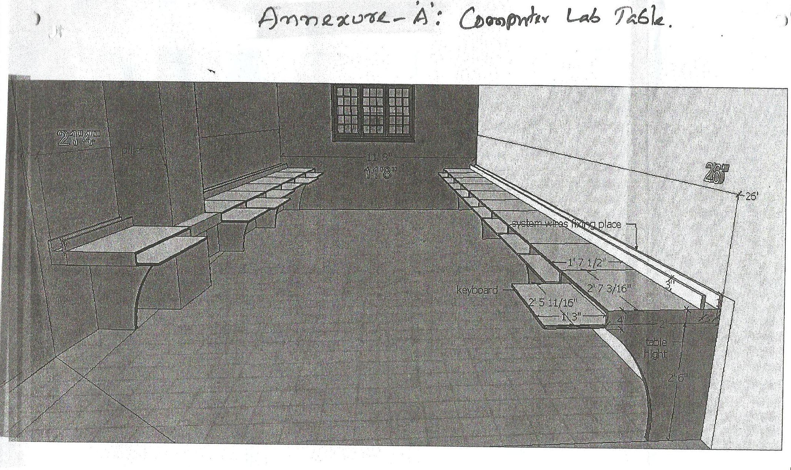
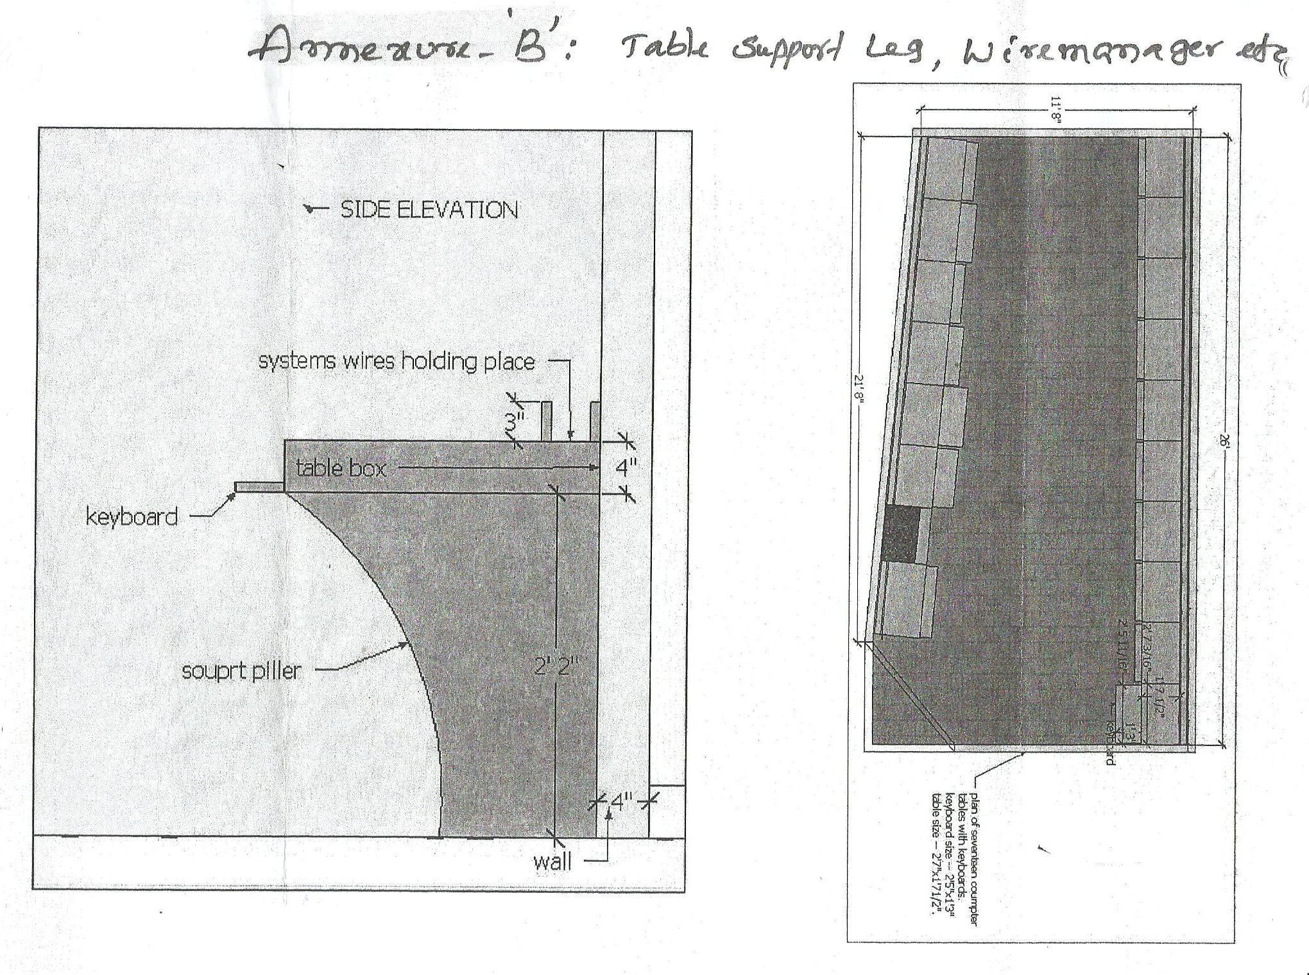

Annexure – III

16. PRICE BID – PART-B

Name of the item: OFFICE FURNITURE FOR COMPUTER LABS
(As per specifications mentioned at Annexure-II)

Sl. No. | Item Description | Quantity | Price  Rs. | Sales Tax/VAT | TOTAL Amount (Rs.)

Note: 1) Items should be delivered and installed at NIPHM.
- Sales tax/VAT should be indicated clearly.
- Prices should be quoted only in Indian rupees.
- Samples of Chairs & Tables as per above description shall be made available at the time of bid evaluation.

We are herewith undertaking that the details provided above are true and to abide by the terms and conditions contained in the bid document of NIPHM.

Signature of authorised official
(With seal and stamp)
Name:
Designation:

ANNEXURE –IV

17. FORMAT FOR AUTHORISATION LETTER

To

The Registrar,
National Institute of Plant Health Management,
Rajendranagar,
HYDERABAD – 500030.
Andhra Pradesh.

Sir,

We hereby authorize _____________________ to submit a Bid and subsequently participate and sign the contract submitted against the Ref.: ____________________________________. We hereby accept his decision taken, if any, in this regard.

(Signature for and on behalf of the Company)
Place:
Date :

ANNEXURE – V

UNDERTAKING

1. I/We undertake that I/We have carefully studied all the terms and conditions and understood the parameters of the proposed supplies of the NIPHM and shall abide by them.

2. I/We also undertake that I/We have understood “Parameters and Technical Specifications for making the supplies” mentioned in Annexure of the Tender dated _______________ and shall make the supplies strictly as per these “Parameters and Technical Specifications for the supplies”.

3. I/We further undertake that the information given in this tender is true and correct in all respect and we hold the responsibility for the same.

Dated at (Dated signature of Bidder with stamp of the firm)

