TENDER NOTICE FOR

Procuring the services to Re-locate/Shifting of laboratory goods/ equipment from LBS Building to newly constructed PMD Building in the same campus of NIPHM, Hyderabad
(Dismantling/De-commissioning, Shifting, Erection, Commissioning and ensuring required Calibration after Re-Installation of Laboratory Equipment)

UNDER PAC BASIS THROUGH

M/s. Agilent Technologies India Pvt. Ltd., 4th Floor, #C#Block, RMZ Centennial, Plot No. 8A, 8B, 8C & 8D, Doddanakundi Industrial Area, ITPL Road, Mahadevapura Post, Bangalore, Karnataka – 560 048

राष्‍ट्रीय वनस्‍पति स्‍वास्‍थ्‍य प्रबंधन संस्‍थान

National Institute of Plant Health Management
कृषि एवं सहकारिता विभाग, कृषि एवं किसान कल्‍याण मंत्रालय, भारत सरकार
Department of Agriculture & Cooperation
Ministry of Agriculture& Farmers Welfare, Government of India

Rajendra Nagar, Hyderabad – 500 030
Website: http://niphm.gov.in
Telephone: 9140-24015374; E-mail: niphm@nic.in; Tele-Fax: 9140-24015346

राष्‍ट्रीय वनस्‍पति स्‍वास्‍थ्‍य प्रबंधन संस्‍थान

National Institute of Plant Health Management
कृषि एवं सहकारिता विभाग, कृषि एवं किसान कल्‍याण मंत्रालय, भारत सरकार
Department of Agriculture & Cooperation
Ministry of Agriculture& Farmers Welfare, Government of India

Telephone: 9140-24015374  E-mail: niphm@nic.in  Tele-Fax: 9140-24015346 |  | Rajendra Nagar,  Hyderabad – 500 030  http://niphm.gov.in

F. No. PMD-Misc/160/2021-JD-Chem/03 Date:- 31/05/2021

SECTION-I: NOTICE INVITING TENDER

UNDER PROPRIETARY ARTICLE CERTIFICATE (BASIS)

- National Institute of Plant Health Management, is an autonomous Institute under Ministry of Agriculture& Farmers Welfare, Govt. of India is mandated to promote environmentally sustainable Plant Health Management Practices in diverse and changing agro-climatic conditions and provide policy support to Central and State Government on Plant Health Management, Sanitary and Phyto-sanitary issues and emerging bio-security challenges.

- NIPHM intends for procurement of for procuring the services to Re-locate/Shifting of laboratory goods/ equipment from LBS Building to newly constructed PMD Building in the same campus of NIPHM, Hyderabad (Dismantling/De-commissioning, Shifting, Erection, Commissioning and ensuring required Calibration after Re-Installation of Laboratory Equipment) under Proprietary Article Certificate (PAC) basis through M/s. Agilent Technologies India Pvt. Ltd., 4th Floor, #C#Block, RMZ Centennial, Plot No. 8A, 8B, 8C & 8D, Doddanakundi Industrial Area, ITPL Road, Mahadevapura Post, Bangalore, Karnataka – 560 048

- The details of the equipment are given below:-

Sl. No. | Name of the Equipment | Model No. | No. of Equipment
 | GC-ECD | GC 7890A | 1
 | GC-FID | GC 7890B | 3
 | GCMSMS | GC-7890 MS 7000 | 2
 | GC-Q-ToF | Agilent CN | 1
 | ICP-OES | Agilent 5100 VDV | 1
 | LC-Q-ToF | Agilent SG | 1
 | Spectrophotometer-UV-Vis | Cary 100 UV-VIS | 1
Total No. of Equipment |  |  | 10

- GST Exemption Certificate is NOT APPLICABLE for this Institute. Please submit your quotation with applicable GST percentage (%).
- Terms and condition applicable as per GFR, 2017 and Manual for Procurement of Goods 2017, etc.
- Tender document is available for viewing on the website of NIPHM, Hyderabad at www.niphm.gov.in.
- Last date of receipt of bid along with quotation is 21/06/2021.
Sd/- REGISTRAR
SECTION-II: SCOPE OF WORK

S. No | Scope of Shifting
1. | Benchmarking of equipment, De-Installation, Soft Packing, Loading, Transport of Equipment from NIPHM Source site to Destination Site and Unloading of Equipment, Re-Installation.
2. | Relocation activity shall be carried out in close coordination with JD(Chem), NIPHM or his/her representative.
3. | Benchmarking of equipment after successful relocation and IQ/OQ or Calibration (one time) of equipment with service persons from respective manufacturers or equivalent supplier.

The following points may kindly be noted:-
- If any equipment [Section-IV: Schedule of Requirement] is found to be not working/under repair at the time of joint benchmarking, such equipment shall also be shifted to new location. However, calibration need not be done by the service provider for such equipment.
- Conditional Bid will not be accepted and summarily be rejected.
- Civil, Electrical, Plumbing and Gas Panels shall be under the scope of NIPHM.
- Re-location work should start and end with joint benchmarking.
- Once the re-location activity starts, the responsibility of safe handling of the equipment rests with Service Provider / bidder.
- No Manpower/logistics support will be provided from NIPHM end to the successful bidder.

SECTION-III: SPECIAL CONDITIONS OF CONTRACT (SCC)

- The bidder shall be required to complete the required work within 30 days of the issuance of work order, failing which Liquidated damages @0.5% of the indent cost per day of delay or part thereof, will be imposed subject to a maximum of 10% of contract value (if the delay is attributable to the bidder).
- Additional Bank Guarantee (BG) towards security of the Government property entrusted:
- Within ten (10) days after the Supplier’s receipt of Award of contract, the successful firm shall require to furnish Additional Bank Guarantee of 10% of the value of the contract before execution of work to ensure safety of the government property and to safeguard purchaser’s interest. The BG should be valid for a period of two months from the date of acceptance of the contract by the agency. This additional BG shall be in addition to the Performance Security of 3% of the value of the contract as specified at Section-V (GCC) under Clause-5.
- Liability Clause- The firm to compensate for any damage caused to the equipment in transit, or during dis-assembling and assembling and final testing of the equipment.
- In case of any loss/damage or any other defects found attributable during/after execution of the work by the agency or in case the services are in contravention with the scope of work mentioned under Section-II, the additional BG will be forfeited to the extent of damage/loss of the equipment(s). The decision of Competent Authority, NIPHM is final in this regard. The Additional BG shall be released only after attending the scope of work (Section-II) and endorsement to that effect by JD (Chem), NIPHM.
- Further, the safety of the government property completely relies with M/s. Agilent, Bangalore, Karnataka and the payment to the agency will be released only after satisfactory execution of the work and endorsement to that effect by JD (Chem), NIPHM.

SECTION-IV: SCHEDULE OF REQUIREMENT
Sl. No. | Name of Equipment (Make and Model) | No. of Equipment | Image of the equipment  (Details of Existing Location & New Location)
 | GC-ECD  Make: Agilent Technologies  Model:7890A | 1 | 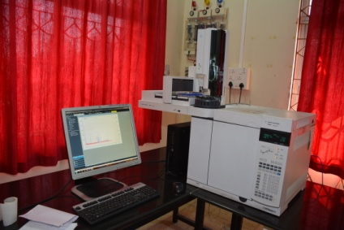  Existing Location: II Floor  New Location: II Floor
 | GC-FID  Make: Agilent Technologies Ltd.  Model: GC 7890B | 3 | 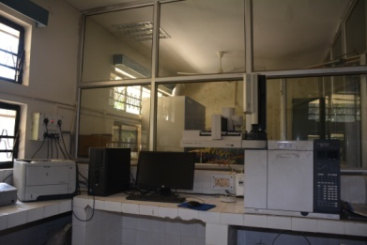  Existing Location: PFA I Floor  New Location: I Floor
 | GC-MS-MS  Make: Agilent Technologies Ltd. Model: GC-7890 MS 7000 | 2 | 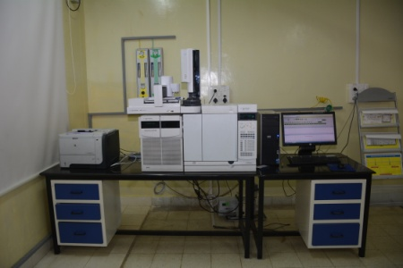 Existing Location: 305 -III floor  New Location: III floor | 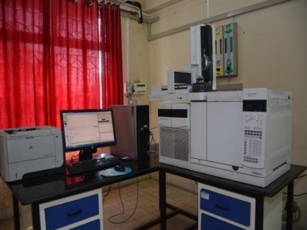  Existing Location: II floor  New Location: II floor
 | GC-Q-ToF  Make: Agilent Technologies Ltd.  Model: Agilent CN | 1 | 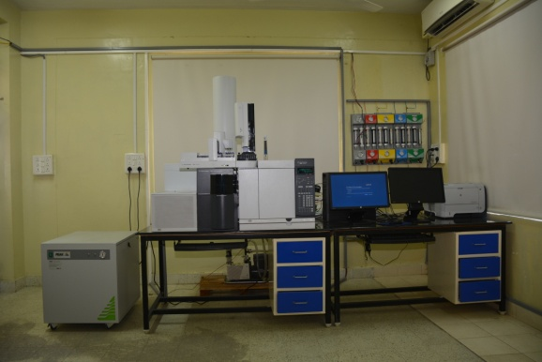  Existing Location: 305-III Floor  New Location: III Floor
 | ICP-OES  Make: Agilent  Model: Agilent 5100 VDV | 1 | 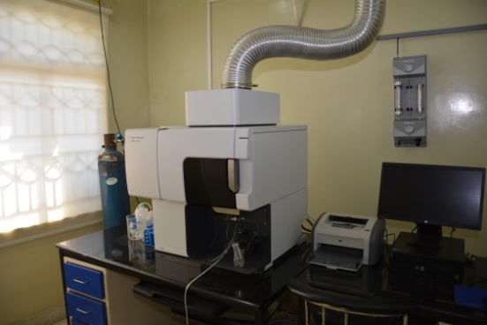  Existing Location: 303- III Floor  New Location: I Floor
 | LC-Q-ToF  Make: Agilent  Model: Agilent SG | 1 | 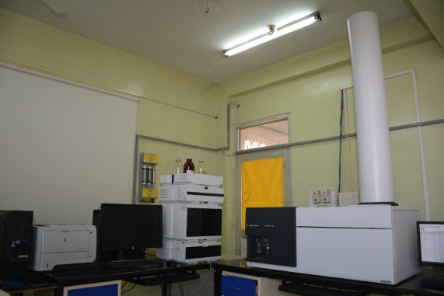  Existing Location: 304-III Floor  New Location: III Floor
 | Spectrophotometer UV-VIS  Make: Agilent  Model: Carry 100 UV-VIS | 1 | 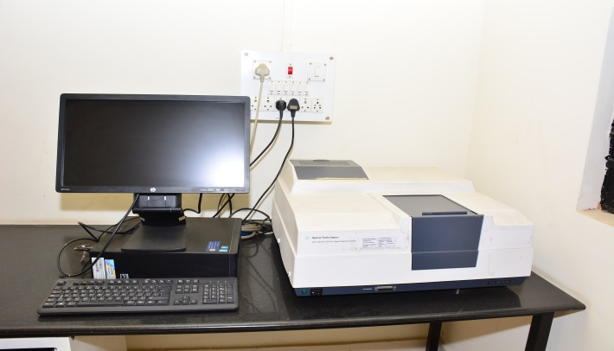  Existing Location: I Floor , PFA  New Location: IV Floor
Total |  | 10

The following are the checklist of documents to be submitted:-

- Proprietary Certificate of the equipment on the Letterhead of Original Equipment Manufacturers (OEM) – Format enclosed at Annexure-I or in their own format.
- Manufactures Authorization Certificate in case of Authorized Dealer.
- A copy of this PAC Tender document signed by the Authorized Signatory with Company seal.

SECTION-V: GENERAL CONDITIONS OF CONTRACT (GCC)

- Bid Security:
In terms of OM No. F.9/4/2020-PPD dated 12th November, 2020 issued by Ministry of Finance, Govt. of India, bidders are requested to sign "Bid Security Declaration" format (Annexure – II) accepting that if they withdraw or modify their bids during period of validity etc., they will be suspended for the time specified in the tender documents.

- The envelope containing the original "Bid Security Declaration" should bear tender details (Name of bidder, tender no., tender name etc.).
- The "Bid Security Declaration" is required to protect the Purchaser against risk of Bidder’s conduct.
- The quotation should be valid for a period of 180 days from the date of opening of the tender. Rates are to be quoted in INR (Rupee terms) only and any revision thereof is not allowed after the tender has been opened.
- Bidder, if is not the Original Equipment Manufacturer (OEM), must submit OEM’s or their Distributor’s Authorization to quote/sell the product(s). Preference will be given to quotation pertaining to indigenous products. However, where suitable substitutes are not available and item need to be imported the following clarification/information should be given:-
- Authorization certificate from Original Equipment Manufacturer (OEM) or their Distributor to quote/sell the product, in case the bidder is not the OEM.
- Whether the item will be imported by the intended tenderers against its own import license or Institute will have to provide Custom Duty Exemption Certificate (CDEC).
- Name and address of the foreign supplier, make & model of the offered product and authorization to sell from OEM or their Distributor/Authorized Chanel Partner.
- Whether the item required any special preparation for installation. In case yes, full details should be given regarding operation, maintenance of the items.
- In case of costly/sophisticated items whether the tenderers will arrange any special training regarding operation / maintenance of the items.
- In the event of the item(s) being imported product(s), Custom Duty Exemption Certificate (CDEC) will be issued by the Institute on the written request of the supplier; who, in turn, will furnish copies of relevant Customs Related Documents namely Airways Bill, Packing List, etc. along with Bill/Invoice.
- Conditional quotations and/or incomplete quotations in any respect will be rejected.
- The specification of the item quoted by the firm should confirm to the Institutes specifications. Confirmation, in this respect should be specifically mentioned in the tender. Where the tenderer feels that the specification of the item not fully given or differ, from the specification of the item mentioned by the Institute, the exact specification of such item should be attached with the tender indicating the item quoted.
- The Firm is required to link the Institutes specifications with catalogues & leaflets/literature and also mention Make and the Model for each item. Detailed features, for compliance of specification should be provided on specification sheet & appropriate reference i.e. page no. & para of literature, leaflet wherefrom the relevant information has been checked, should be indicated.
- Negotiations: Negotiations will be held with your agency by a Negotiation Committee constituted by the Competent Authority, NIPHM. The date, time and venue will be intimated in due course of time. Authorized representative from your agency is requested to attend the meeting.
- Payment of Performance Security (PS): Within ten (10) days after the Supplier’s receipt of Notification of Award, the Successful firm(s) shall require to deposit 3% of the order value as Security deposit/Performance Security either by means of demand draft or bankers Cheque or Bank Guarantee from any nationalized/Scheduled banks in favour of National Institute of Plant Health Management (NIPHM), Hyderabad which should be valid beyond 60 days from the date of completion of all contractual obligations of the supplier including warranty obligation. The security deposit will be released/discharged after 60 days of completion all contractual obligations of the supplier including warranty obligation.

The security deposit shall be forfeited, if the successful bidder fails to supply the stores/services as per specifications mentioned in the tender/P.O or does not accept the assigned work for any reason, whatsoever.
- The bidder has to submit an undertaking in firm letter pad that it has not been blacklisted by any Govt./Instt/autonomous body.
- OEM/authorized distributor should accept a fall clause and give an undertaking that, in case it supplies or quotes a lower rate to other Governments, Public Sector or Private Organisation, it would reimburse the excess.
- Proprietary Article Certificate from the Manufacturer.
- Consignee: Registrar, National Institute of Plant Health Management (NIPHM), Rajendrangar, Hyderabad – 500 030
- Terms of Supply: The firm should complete the services within 30 days from the date of issue of work order.
- The Institute reserves the right at the time of award of PO/Contract to increase or decrease the quantity of goods and services originally specified in the Schedule of Requirements without any change in unit price or other terms and conditions.
- Liquidated Damages: If the Supplier fails to deliver any or all of the Goods or to perform the Services within the time period(s) specified in the Contract, the Purchaser shall, without prejudice to its other remedies under the Contract, deduct from the Contract Price, as liquidated damages, at the rate of 0.5% of the contract price of the delayed Goods or unperformed Services for each week or part thereof of delay until actual delivery, submission of documents and performance, up to a maximum deduction is 10% of the contract price. The delivery of goods means delivery of goods/services with in the delivery period including installation. Once the maximum is reached, the Purchaser may consider termination of the Contract.
- If the goods supplied are rejected, the same shall be removed from the premises by the supplier within 15 days of intimation from this Institute. This institute will not take any responsibility for the rejected stores thereafter.
- Terms of Payment:
- Payment will be released within 30 days after supply and final acceptance by the officer to that effect subject to recoveries, if any, by way of liquidated damages or any other charges as per terms & conditions of contract in the following manner.
- All the payment shall be made by Cheque/DD/RTGS/NEFT after supply and final acceptance by the designated officer.
- 100% payment of the contract price shall be paid on receipt of goods in good condition at the consignee premises and Certification of goods to be issued by the consignees subject to recoveries, if any, either on account of defects/ deficiencies not attended by the supplier or otherwise and upon the submission of the following documents:
- The Supplier/firm should submit the invoice in triplicate. The invoice should contain the GST registration number and there should not be any overwriting/cuttings/corrections. An advance stamped receipt should be enclosed along with invoice.
- Two copies of packing list identifying contents of each package.
- The supplier shall not claim any interest on payment under the contract.
- Where there is a statutory requirement for tax deduction at source, such deduction towards income tax and other tax as applicable will be made from the bills payable to the supplier rates as notified from time to time.
- No payment shall be made for rejected stores. Rejected items must be removed by the supplier within two weeks of the date of issue of rejection advice at their own cost & replace immediately. In case these are not removed these will be auctioned at the risk and responsibility of the suppliers without notice.
- No additional service charges for fixing the spare parts to the equipment will be allowed.
- GST:- The GST taxes where legally leviable and intended to be claimed should be distinctly shown in the Tax Invoice submitted by the Seller after supply of the items. Where this is not done it will be treated that the price is inclusive of GST. GST registration No. and date of its validity should be indicated. The firm must quote their TIN No., PAN No., (IT returns) etc. in the quotation (attested copies to be enclosed). The agency is requested to indicate NIPHM GST No.36AAAAN9355N1ZZ on the tax invoice.
- The supply will be accepted only, if the offered items are in accordance with the quality and quantity (as per required pack size mentioned in the Purchase Order) as per technical specifications of NIPHM. No Deviation will be accepted. The quantity of items may be increased or decreased depending on the actual need/requirement of NIPHM.
- The supplier shall not be entitled to any increase in the rates.
- The supplier will be fully responsible for any loss in transit and will also be responsible for safe delivery of the goods/stores in good conditions at NIPHM.
- The Competent Authority reserves the right to reject any or all the tenders and annual the bidding process at any time prior to award of Contract, without assigning any reason, without thereby incurring any liability to the affected Bidder or Bidders, and his decision will be final.
- Inspections and Tests
- The Supplier shall provide for each item a Manufacturer’s Quality certificate that the item conforms to specifications laid down in this Contract.
- Goods shall not be dispatched/ shipped unless a satisfactory Manufacturer’s Quality certificate, as above, has been issued in respect of those goods.
- The Purchaser / Consignee reserve the right to inspect the goods before acceptance. If the goods fail to meet the Contract specifications after their receipt at the Consignee’s end, the supplier shall take immediate steps to remedy the deficiency or replace the defective component/ equipment to the satisfaction of the Purchaser/consignee.
- Pre-dispatch Inspection: The Purchaser or his representative may, at his option, inspect and/or test any or all items of the goods to confirm their conformity to the Contract, prior to dispatch from the manufacturer’s/ supplier’s premises. Such inspection and clearance will not prejudice the right of the consignee to inspect and test the equipment on receipt at destination.
- Force Majeure conditions: If at times during the continuance of the Agreement/Contract, it becomes impossible by reason of war or war- like operations, epidemics, pestilence, earthquake, fire storm or floods, the firm shall during the continuance of such contingencies not be bound to execute the contract as per the agreement/contract.

The work shall be resumed immediately after the contingency/cies has/have ceased otherwise determined and the Successful Bidders obligations shall continue to be in force for correspondingly extended period after the resumption of execution. The successful Bidders shall however inform the NIPHM by registered post/fax about such Act duly certified by the commissioner of Labor at the beginning and end of the above causes of delay within 10 (ten) days of occurrence and cessation of such Force Majeure conditions.

In the event of delay lasting over one month, if arising out of cause of Force Majeure, the NIPHM reserves the right to cancel the contract without any compensation. Only events of Force Majeure which affects the order progressing at the time of its occurrence shall be taken in to cognizance. The NIPHM shall not be liable to pay extra costs due to delayed supplies made under Force Majeure.
- Disputes and Arbitration:
- All matters relation to any dispute which may arise during the execution of the contract shall be referred to Arbitration of an Arbitrator to be mutually agreed upon between the parties. On the whole, provisions of the Arbitration and Conciliation Act, 1996 shall prevail.
- The venue of such Arbitration shall be at Hyderabad only. Arbitration suits or any other claims filed in any Court of Law outside Hyderabad City will not be binding on NIPHM.
- Jurisdiction: Subject to the above Clause, it is hereby agreed that Hyderabad City shall have jurisdiction to decide or adjudicate upon any dispute which may arise out of or be in connection with this contract agreement. The contract shall be governed by the Laws of Union of India/Government of Telangana in force.
- Assignment: The Supplier shall not assign, in whole or in part, its obligations to perform under the Contract, except with the Purchaser’s prior written consent.
- Subcontracts: Assignment of the contract is not allowed and the bidder himself has to execute the contract of supplying the instruments. Further all the analytical Instruments must have been manufactured by the same Industry/Company, except the Personal computer and its accessories like UPS etc.
- Governing Language:- The contract shall be written in the English language. The version of the Contract written in the English language shall govern its interpretation. All correspondence and documents pertaining to the Contract which are exchanged by the parties shall be written in English only.
- Applicable Law:- The Contract shall be interpreted in accordance with the laws of the Union of India.
- Notices
- Any notices given by one party to the other, pursuant to this Contract shall be sent to the other party in writing or by email or facsimile and confirmed in writing to the purchaser. For this purpose, the Purchaser’s address is specified below:
National Institute of Plant Health Management Rajendranagar, Hyderabad -500030.
- A notice shall be effective when delivered or on the notice’s effective date, whichever is later.
- Taxes and Duties
- A Foreign Supplier shall be entirely responsible for all taxes, stamp duties, license fees, and other such levies imposed outside the India as well as within India till the delivery of the contracted goods to the purchaser.
- Custom Duty shall be paid in Indian currency on submission of documentary evidence, only on the Foreign goods. GST will be paid in Indian currency.
- A Local Supplier shall be entirely responsible for all taxes, duties, and license fees etc., incurred until delivery of the contracted Goods to the Purchaser.
- Statutory variation in Custom Duty and GST on finished product within the original Delivery Period will be on purchaser’s account.
- The purchaser shall not be liable to any claim on account of fresh imposition and/or increase of Custom Duty and GST on raw materials and/or components used directly in the manufacture of the contracted stores taking place during the currency of the contract.

Annexure – I
ON THE LETTERHEAD OF ORIGINAL EQUIPMENT MANUFACTURER
To whom it may concern
Date:
PROPRIETARY CERTIFICATE

We, …………………………..with our factories at ………………………………, hereby certify that the following parts quoted (Quotation No………………….Dt:………………………) are articles of proprietary in nature, and we ……………………………..are the original manufacturer of the said items
The items mentioned below are solely manufactured by us and not by anyone else in the entire world.
Sl. No. | Name of the Equipment | Model No. | No. of Equipment
 | GC-ECD | GC 7890A | 1
 | GC-FID | GC 7890B | 3
 | GCMSMS | GC-7890 MS 7000 | 2
 | GC-Q-ToF | Agilent CN | 1
 | ICP-OES | Agilent 5100 VDV | 1
 | LC-Q-ToF | Agilent SG | 1
 | Spectrophotometer-UV-Vis | Cary 100 UV-VIS | 1
Total No. of Equipment |  |  | 10

Thanking you,

Signed for

(Company Name)
Authorized signatory
ANNEXURE – II

BID SECURITY DECLARATION FORM

Date:___________________
Tender No. _________________

To (insert complete name and address of the purchaser)

I/We. The undersigned, declare that:

I/We understand that, according to your conditions, bids must be supported by a Bid Securing Declaration.

I/We accept that I/We may be disqualified from bidding for any contract with you for a period of TWO years from the date of notification if I am /We are in a breach of any obligation under the bid conditions, because I/We

have withdrawn/modified/amended, impairs or derogates from the tender, my/our Bid during the period of bid validity specified in the form of Bid; or

having been notified of the acceptance of our Bid by the purchaser during the period of bid validity (i) fail or reuse to execute the contract, if required, or (ii) fail or refuse to furnish the Performance Security, in accordance with the Instructions to Bidders.

I/We understand this Bid Securing Declaration shall cease to be valid if I am/we are not the successful Bidder, upon the earlier of (i) the receipt of your notification of the name of the successful Bidder; or (ii) thirty days after the expiration of the validity of my/our Bid.

Signed: (insert signature of person whose name and capacity are shown)
in the capacity of (insert legal capacity of person signing the Bid Securing Declaration)

Name: (insert complete name of person signing he Bid Securing Declaration)
Duly authorized to sign the bid for an on behalf of (insert complete name of Bidder)
Dated on _____________ day of ___________________ (insert date of signing)

Corporate Seal (where appropriate)

(Note: In case of a Joint Venture, the Bid Securing Declaration must be in the name of all partners to the Joint Venture that submits the bid)

Annexure – III

MANUFACTURER’s / PRINCIPAL’s AUTHORIZATION FORM
To
The Registrar,
National Institute of Plant Health Management (NIPHM),
Rajendranagar,
Hyderabad

Dear Sir,

TENDER: __________________________________________________.

we, ______________________________________, who are established and reputable manufacturers of ________________, having factories at __________________ and____________________, hereby authorize Messrs. (Authorised Dealer/Sole Distributor/Supplier)_______________________ (name and address of agents) to bid, negotiate and conclude the contract with you against Tender No.__________________ for the above goods manufactured/ services to be rendered by us. No company or firm or individual other than Messrs. _________________________ are authorized to bid, negotiate and conclude the contract in regard to this business against this specific tender.

The authorization is valid up to ___________________________________________________

Yours faithfully,

(Name)

For and on behalf of M/s. ______________ (Name of manufacturers)/Principal

  - Annexure – IV

FORMAT FOR UNDER TAKING

UNDERTAKING
- मैं/हम वचन देता हूं /देते हैं कि मैंने/हमने सभी निबंधन एवं शर्तों को सावधानीपूर्वक अध्‍ययन कर लिया है एवं रावस्‍वाप्रसं (एनआईपीएचएम) के प्रस्‍तावित आपूर्ति संबंधी मानदण्‍डों को समझ लिया है तथा उल्‍लिखित सभी मानदंडों का अनुपालन करूंगा/करेंगे।
I/We undertake that I/We have carefully studied all the terms and conditions and understood the parameters of the proposed supplies of the NIPHM and shall abide by them.
- मैं/हम यह भी वचन देता हूं/ देते हैं कि मैंने/हमने “दिनांक------------------------ के निविदा के संलग्‍नक-IIमें उल्‍लिखित आपूर्ति करने संबंधी मानदण्‍डों एवं तकनीकी विनिर्देशन विशिष्‍टि” को समझ लिया है एवं “आपूर्ति संबंधी मानदण्‍डों एवं विनिर्देशन विशिष्‍टि’ के अनुसार आपूर्ति करूंगा/करेंगे” ।
I/We also undertake that I/We have understood “Parameters and Technical Specifications for making the supplies” of the Tender dated _______________ and shall make the supplies strictly as per these “Parameters and Technical Specifications for the supplies”.
- यह प्रमाणित करना है कि उद्धृत दरें समान हैं और किसी भी अन्य सरकारी, सार्वजनिक क्षेत्र या निजी संगठनों के साथ उद्धृत की तुलना में अधिक नहीं हैं।
It is to certify that the rates quoted are the same and not higher than those quoted with any other Government, public sector or private organizations.

- मैं/हमआगेयहभीवचनदेताहूं /देतेहैंकिइसनिविदामेंसभीसंदर्भोंमेंदीगईसूचनाएंमेरीअधिकतमजानकारीकेअनुसारसहीऔरसत्‍यहैएवंमैं/हमइसकेप्रतिपूरीजिम्‍मेदारीलेताहूं /लेतेहैंतथाफर्म/कंपनी किसी भी सरकार कार्यालय / मंत्रालय / विभाग / पीएसयू / प्रतिष्ठित संगठन और बैंक आदि द्वारा काली सूची में सूचीबद्ध नहीं किया गया है
I/We further undertake that the information given in this tender is true and correct in all respect and we hold the responsibility for the same and the firm/ Company has not been black listed by any Govt. office/ministry/Department/PSUs/ reputed organization and Banks etc.

दिनांक : (कंपनी के मोहर सहित निविदाकार के हस्‍ताक्षर एवं दिनांक)
Dated at (Dated signature of Bidder with stamp of the firm)
~~~

