इ–निविदा सूचना
SHORT e-TENDER NOTICE

Calling of Short E-Tender Notice for procuring the services to Re-locate/Shifting of laboratory goods/ equipment from LBS Building to newly constructed PMD Building in the same campus of NIPHM, Hyderabad on Turnkey basis
(Dismantling/De-commissioning, Shifting, Erection, Commissioning and ensuring required Calibration after Re-Installation of Laboratory Equipment)

राष्‍ट्रीय वनस्‍पति स्‍वास्‍थ्‍य प्रबंधन संस्‍थान

National Institute of Plant Health Management
कृषि एवं सहकारिता विभाग, कृषि एवं किसान कल्‍याण मंत्रालय, भारत सरकार
Department of Agriculture & Cooperation
Ministry of Agriculture& Farmers Welfare, Government of India

Rajendra Nagar, Hyderabad – 500 030
Website: http://niphm.gov.in
Telephone: 9140-24015374; E-mail: niphm@nic.in; Tele-Fax: 9140-24015346

TABLE OF CONTENTS

Section | Particulars | Page No.
I | Notice Inviting Tender (NIT) | 3-4
II | Instructions to Bidders (ITB) | 5-8
III | Eligibility and Qualification Criteria | 9-10
IV | Schedule of requirements | 11-27
V | General Conditions of Contract (GCC) | 28-59
VI | Standard Formats | 60-70

राष्‍ट्रीय वनस्‍पति स्‍वास्‍थ्‍य प्रबंधन संस्‍थान

National Institute of Plant Health Management
कृषि एवं सहकारिता विभाग, कृषि एवं किसान कल्‍याण मंत्रालय, भारत सरकार
Department of Agriculture & Cooperation
Ministry of Agriculture& Farmers Welfare, Government of India

Telephone: 9140-24015374  E-mail: niphm@nic.in  Tele-Fax: 9140-24015346 |  | Rajendra Nagar,  Hyderabad-500030  http://niphm.gov.in
F. No. PMD-Misc/160/2020-JD-Chem/03 Date: December 17, 2020
इ–निविदा सूचना
SHORT e-TENDER NOTICE
SUBJECT: Short e-Tender Notice for procuring the services to Re-locate/Shifting of laboratory goods/ equipment from LBS Building to newly constructed PMD Building in the same campus of NIPHM, Hyderabad on Turnkey basis (Dismantling/De-commissioning, Shifting, Erection, Commissioning and ensuring required Calibration after Re-Installation of Laboratory Equipment)
I am directed to invite online tenders from respective manufacturers of the equipment (mentioned at Section IV. Schedule of Requirement) /competitive product manufacturers/agencies dealing with same kind of equipment for procuring the services to Re-locate/Shifting of laboratory goods/ equipment from LBS Building to newly constructed PMD Building in same campus of NIPHM, Hyderabad on Turnkey basis (Dismantling/De-commissioning, Shifting, Erection, Commissioning and ensuring required Calibration after Re-Installation of Laboratory Equipment).

Name of Work | Estimated Cost Put to Tender (ECPT) including GST (Rs. In lakhs) | Period of completion of work
Procuring the services to Re-locate/Shifting of laboratory goods/ equipment from LBS Building to newly constructed PMD Building in same campus of NIPHM, Hyderabad on Turnkey basis (Dismantling/De-commissioning, Shifting, Erection, Commissioning and ensuring required Calibration after Re-Installation of Laboratory Equipment) | Rs.51.92 lakhs | 30 days
The equipment/goods are presently located at LBS Building, NIPHM, Hyderabad. After dismantling these equipment/goods are to be transported to newly constructed PMD Building, NIPHM, Hyderabad-50030 i.e., within the same campus. Complete details of equipment are given in (mentioned at Section IV. Schedule of Requirement) along with details of existing location, new location and image of the equipment.
Important Dates:-
 | Site Visit | The bidders are free to visit the site before participating in the Tender
 | Bid submission start date | Date:- 18/02/2021; Time:- 16.30 Hrs
 | Last date & time of receipt of tenders | Date: 23/02/2021; Time:- 16.30 Hrs
 | Date & Time of opening of technical bid:- | Date: 24/02/2021 Time:- 16.00 Hrs
 | Date & Time of opening of financial bid:- | To be notified at a later date
Sd/-
Registrar I/c
SECTION I. NOTICE INVITING TENDER (NIT)

- National Institute of Plant Health Management, is an autonomous Institute under Ministry of Agriculture& Farmers Welfare, Govt. of India is mandated to promote environmentally sustainable Plant Health Management Practices in diverse and changing agro-climatic conditions and provide policy support to Central and State Government on Plant Health Management, Sanitary and Phyto-sanitary issues and emerging bio-security challenges.

- NIPHM invites online tenders from respective manufacturers of the equipment (mentioned at Section IV. Schedule of Requirement)/competitive product manufacturers/agencies dealing with same kind of equipment for procuring the services to Re-locate/Shifting of laboratory goods/ equipment from LBS Building to newly constructed PMD Building in same campus of NIPHM, Hyderabad on Turnkey basis (Dismantling/De-commissioning, Shifting, Erection, Commissioning and ensuring required Calibration after Re-Installation of Laboratory Equipment).

- Interested parties may please send their bids on-line through http://eprocure gov.in/eprocure via two bid system Technical Bid & Financial Bid. For further details and obtaining of the tender documents, tender notices may be seen at the website of NIPHM i.e., www.niphm.gov.in. Bids received after stipulated date and time shall not be entertained. Financial bids of technically qualified, eligible bidders meeting all the requisite criteria only shall be opened on a date & place to be notified later in presence of technically qualified bidders or their authorized representatives.

- Incomplete or conditional tenders will not be entertained.

- Bid Security:
In terms of OM No. F.9/4/2020-PPD dated 12th November, 2020 issued by Ministry of Finance, Govt. of India, bidders are requested to sign "Bid Security Declaration" Format (Annexure–II) accepting that if they withdraw or modify their bids during period of validity etc., they will be suspended for the time specified in the tender documents.

- The envelope containing the original "Bid Security Declaration" should bear tender details (Name of bidder, tender no., tender name etc.).
- The "Bid Security Declaration" is required to protect the Purchaser against risk of Bidder’s conduct.
- The bidders claiming exemption from submission of "Bid Security Declaration" shall submit valid NSIC/DIPP/MSEs certificate and such certificate shall be valid on the date of submission of bid and as per Public Procurement Policy for Micro and Small Enterprises (MSEs) order, 2012.
- The bidders who are Micro and Small Enterprises participating in the tender shall enclose with their Bid a copy of Udyog Aadhar Memorandum (UAM) along with their valid registration certificate with District Industries Centres or NSIC or any other body specified by Ministry of Micro and Small enterprises in support of their being an MSE. Such bidders will be exempted from submission of “Bid Security Declaration”.

SECTION II. INSTRUCTIONS TO BIDDERS (ITB)
- Bid Validity:-

- Bids shall remain valid for a period of 180 (one hundred and eighty) days after the last date of Bid submission prescribed by the Purchaser. A bid valid for a shorter period shall be rejected by the Purchaser as non-responsive.
- In exceptional circumstances, the Purchaser may solicit the Bidder’s consent to an extension of the period of validity. The request and the responses thereto shall be made in writing. The “bid security declaration” provided shall also be suitably extended. A Bidder may refuse the request without forfeiting its bid security. However, a Bidder agreeing to the request will not be required nor permitted to modify his bid.

- Scope of the work, terms of supply:

S. No | Scope of Shifting
 | For the equipment listed in Table. No. A (a)
1. | Benchmarking of equipment, De-Installation, Soft Packing, Loading, Transport of Equipment from NIPHM Source site to Destination Site and Unloading of Equipment, Re-Installation.
2. | Supervise relocation activity along with close coordination of all mutually agreed activity along with status updates.
3. | Benchmarking of equipment after successful relocation and IQ/OQ or Calibration (single) of equipment with service persons from respective manufacturers or equivalent supplier.
 | For the equipment listed in Table. No. A (b)
4. | Same as Point 1 to 3 above in this table except Calibration of equipment as noted in Point No.3.
 | For the equipment listed in Table. No. C
5. | Loading, Transportation of Equipment from NIPHM Source site to Destination Site and Unloading of Equipment and placing at designated location.

The following points may kindly be noted:-

- If any equipment [listed under Table-A (a)] is found to be not working/under repair at the time of joint benchmarking, such equipment shall also be shifted to new location. However, calibration need not be done by the service provider.
- Conditional Bids will not be accepted and summarily will be disqualified.
- The quoted value in BoQ should be full and final and should include all incidental costs. Nothing is provisional at the time of quoting BoQ. Further, there is no scope for any negotiations.
- Civil, Electrical, Plumbing and Gas Panels shall be under the scope of NIPHM.
- Re-location work should start and end with joint benchmarking
- Once the re-location activity starts, the responsibility of safe handling of the equipment rests with Service Provider / successful bidder.
- No Manpower/logistics support will be provided from NIPHM end to the successful bidder.

- Payment of Performance Security (PS):
- Within five (5) days after the Supplier’s receipt of Notification of Award, the Successful firm(s) shall require to deposit 3% of bid value as Security deposit/Performance Security either by means of demand draft or bankers Cheque or Bank Guarantee from any nationalized/Scheduled banks in favour of National Institute of Plant Health Management (NIPHM), Hyderabad which should be valid beyond 60 days from the date of completion of all contractual obligations of the supplier including warranty obligation. The security deposit will be released/discharged after 60 days of completion all contractual obligations of the supplier including warranty obligation.
- The security deposit shall be forfeited, if the successful bidder fails to execute the work as per specifications mentioned in the tender/P.O or does not accept the assigned work for any reason, whatsoever.
- If successful Tenderer(s) fails to furnish the required bank guarantee within the specified period, the bidder will be disqualified for two years.

- Submission of Tender through Online:-
The Tender proposes two stage tender systems viz. (1) Technical Bid and (2) Price Bid.

I | Technical Bid | : | Bidders are requested to upload the required scanned copies of files as per the following:-
 | File-1 | : | Profile of the Company/Firm – stating whether the firm is partnership/registered under the Companies Act along with its necessary enclosures. Scanned copy of Company/Firm Information (filled & signed) as per Appendix – I.
 | File-2 | : | Proofs in support of eligibility criteria as per the tender.  Scanned copies of the documents / information (filled & signed) as per the ‘Eligibility Criteria’ (Section -III).
 | File-3 | : | Scanned copy of Technical compliance sheet (filled & signed) for the items mentioned at Schedule of Requirement (Section-IV).
 | File-4 | : | Authorization letter and undertaking (as per Annexure-VI and Annexure-VII) from the Competent Authority of the Company to sign this Tender document. Documents received without such authorization will not be considered for further processing. This is not applicable if the proprietor signs himself as competent authority.

II | Price Bid | : | BoQ Document
 | File-1 | : | Bidders are required to download the BOQ file, open it and fill the data in cells (Col.6 along with "Name of the bidder" row only (having background colour) with their respective commercial quotes and name of the bidder. No other cells should be changed. Once the details have been completed, the bidder should save it and submit it online, without changing the filename. If the BOQ file is found to be modified by the bidder, the bid will be rejected.

Note:
- The Bidders should furnish the location with addresses and license details of the firm.
- The Bidders shall furnish as part of the bid, documents establishing the Bidders eligibility to bid and its qualifications to perform the Contract if their tender is accepted.
- The documentary evidence of the Bidder's qualifications shall be established to the satisfaction of NIPHM. However, the decision of Director General, NIPHM will be final in this regard.

- Price Bid
  - PRICE BID / BOQ (In xls. Format only). Financial Bid as BoQ_XXXX.xls to be filled online & submitted. Please note that the file name should not be changed.
  - Price Bid Evaluation: Opening of Price Bid: Bidders who are qualified in Technical Bid only will be called for Price Bid opening. The technically qualified bidders alone will be informed about the date and time of opening of the Price Bid and their Price Bids alone will be opened on the due date and time in the e-procurement portal. The contract will be entrusted to the Bidder, whose bid has been determined as L1. L1 will be arrived after considering basic price (inclusive of all incidental charges, if any) except GST. GST as applicable will be paid over and above the basic rate after successful completion of services and upon submission of tax invoice. In case the L1 agency who has been awarded the e-tender fails to execute the contract, NIPHM reserves the right to take legal action to get such firms black listed.

  - Appendix – I

- BIDDER’S PROFILE- PART-A:-

1 | THE FIRM  - Name  - Regd. Address  - Address for correspondence  - Authorized Contact Person’s details who is handling the subject matter  i) Name & Designation  ii) Address  iii) Tel. No. Landline & mobile  iv) Email ID
2 | Type of Firm | - SoleProprietor/Private Ltd. / Partnership / Co-operative / Public Co.  - (Pl. tick and enclose copy of Memorandum/Articles of Association/ Certificates of Incorporation)

  - Signature of authorised signatory

  - Name : ______________________

  - Designation ___________________

  - Seal :

SECTION III. ELIGIBLITY & QUALIFICATION CRITERIA
Technical bid should include photocopies of the following documents, duly self-attested, failing which their bids shall be summarily/out rightly rejected and will not be considered any further:
- Registered Office or one of the Branch Office of the Company/ Firm/ Agency should be located anywhere in mainland of India.
- The bidder should possess valid GST Registration. Self-attested copy of the same must be submitted with the technical bid duly bearing seal of bidding firm/agency.
- The bidder should possess valid PAN Card. Self-attested copy of the same must be submitted with the technical bid duly bearing seal of bidding firm/agency.
- The Company/Firm/Agency should submit the technical Bid in prescribed Proforma as mentioned under “Documents to be submitted under Technical Bid” with self-attested copies of documents indicated in compliance with the above requirements should be kept with the Technical Bids.
- The Bidder / OEM, should have executed project for supply and installation / commissioning of same or similar Category Products in Ministries/Departments/Organisations of the Government of India/State Government, PSUs, Nationalised Banks, Private Firm etc. during preceding 5 financial years (i.e. current year and four previous financial years) up to JAN 2021, as per following criteria:
(i) Single order of at least 80% of estimated bid value; or
(ii) Two orders of at least 50% each of estimated bid value; or
(iii) Three orders of at least 40% each of estimated bid value.
Satisfactory completion certificate issued by respective Buyer Organization for the above Orders should be uploaded with bid.
- Copies of IT return of last 2 years AY 2018-19 and 2019-20.
- Undertaking stating that the Company/Firm/Agency is/has not been blacklisted by Central/State Govt./ PSU (Annexure-VII).
- Tender document with all pages duly signed and embossed with official seal.
- Annual turnover proof for the FY 2017-18 to 2019-20
- In respect of manufacturers gross annual turnover of Rs.16 lakhs (Rupees sixteen lakhs only) at least for one year during last three financial years (2017-18 to 2019-20)
- In respect of authorized dealer, the turnover of the manufacturer will be taken into account. In respect of other bidders the annual gross turnover should be at least Rs. 13 lakhs (Rupees thirteen lakhs only) at least for one year during last three financial years. Turnover is not applicable to registered suppliers with MSME/NSIC registered Units subject to submission of supporting documents.

General Terms and Conditions:
- Tender follows a two bid system: a) Technical Bids and b) Financial Bids.
- Experience certificate if any, of similar work in other Ministries/Departments may be submitted along with technical bid.
- The lowest quoted bidder shall be selected on the basis of total bid price received after adding all incidental costs except applicable GST.
- Incomplete/Conditional bids are liable to be rejected.
- Bids received after the closing date shall not be considered.
- Bids once submitted shall not be allowed to be withdrawn.
- The bidders may inspect the items on predetermined dates specified in the tender and satisfy themselves about the items they are bidding for.
- It will be the sole responsibility of the successful bidder to ensure the safety of the structure and other materials to save them from damage etc. at the time of removing, lifting, carting, etc. Repairs/damage if any during the process of dismantling would be borne by the successful bidder.
- Payment will be made within 30 working days after completion of work and receipt of satisfactory report from PMD Division of this Institute.
- NIPHM reserves the right to accept or reject any/all bids without assigning any reason whatsoever.
- General Conditions of Contract (GCC) shall form part of this Tender Document (attached separately).

Special Conditions of Contract (These provisions shall always prevails over GCC):
- The successful bidder shall be required to complete the required work within 30 days of the issuance of work order, failing which Liquidated damages @0.5% of the indent cost per day of delay or part thereof, will be imposed subject to a maximum of 10% of contract value (if the delay is attributable to the bidder).
- One time successful Calibration for the equipment listed in Table. No. A (a) with service persons from respective manufacturers or equivalent supplier within 10 days after joint benchmarking after re-installation of all equipment under the supervision of Joint Director (Chemistry).
- Additional Bank Guarantee (BG) towards security of the Government property entrusted:
- Within five (5) days after the Supplier’s receipt of Award of contract, the successful firm shall require to furnish Additional Bank Guarantee for Rs.40 lakhs before execution of work to ensure safety of the government property and to safeguard purchaser’s interest. The BG should be valid for a period of two months from the date of acceptance of the contract by the agency. This additional BG shall be in addition to the Performance Security as specified at Section-II (ITB) Clause-3 (Page-5).
- In case of any loss/damage or any other defects found attributable during/after execution of the work by the agency, the additional BG will be forfeited to the extent of damage/loss of the equipment(s). The decision of Competent Authority, NIPHM is final in this regard.
- The Additional BG shall be released only after attending special conditions of contract point no.2 and endorsement to that effect by JD(Chem), NIPHM.

SECTION IV. SCHEDULE OF REQUIREMENT

Table: A (a) List of assets and equipment’s to be relocated (To be calibrated)
Sr. No. | Name of Equipment (Make and Model) | No. of Equipment | Image of the equipment  (Details of Existing Location & New Location)
 | Analytical Balance  Make: Sartorius  Model: CPA225D | 1 | 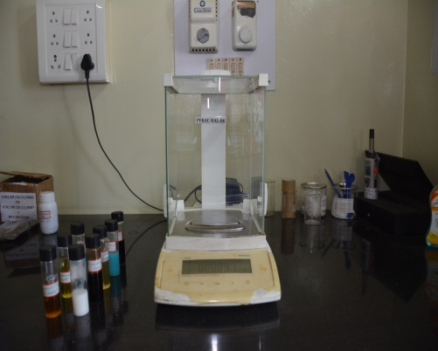  Existing Location: III Floor Sample Prep. Room  New Location: III Floor
 | Analytical Balance  Make: Mettler Toledo  Model: SM 205DU | 1 | Existing Location: II Floor -LBS  New Location: II Floor
 | Deep Freezer  Make: Tata  Model: Voltas | 2 | 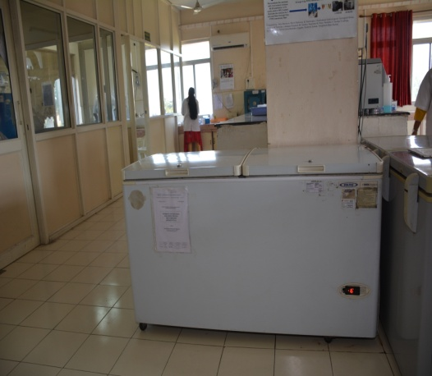  Existing Location: II Floor Sample Prep. Room  New Location: II Floor
 | Deep Freezer  Make: Elanpro  Model: EF-450 | 2 | 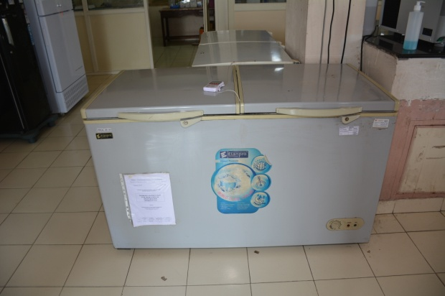  Existing Location: II Floor Sample Prep. Room  New Location: II Floor | Existing Location: I Floor  New Location: PT I Floor
 | Deep Freezer  Make: Venchal Scientific  Model: 2512-450 | 2 | Existing Location: PT I Floor  New Location: PT I Floor
 | Deep Freezer  Make: H-Bio  Model: DF25U455 | 2 | Existing Location: II Floor Sample Prep. Room  New Location: II Floor
 | Deep Freezer  Make: Jove Automation  Model: JA DF 30 | 1 | 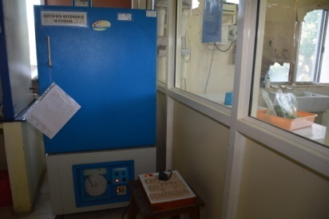  Existing Location: II Floor Sample Prep. Room  New Location: II Floor
 | GC-FID  Make: Agilent Technologies Ltd.  Model: GC 7890B | 1 | 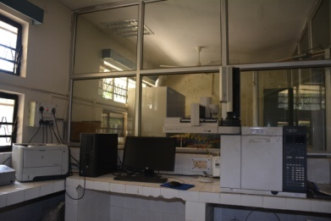  Existing Location: PFA I Floor  New Location: I Floor
 | Hot Air Oven  Make: Lead Instrument  Model: LI – HAO | 2 | Existing Location:II Floor(2 No.)  New Location: II Floor(2 No.)
 | HPLC - PDA  Make: Shimadzu  Model: Nexera XR SIL | 1 | Existing Location: I Floor PFA  New Location: I Floor
 | HPLC – PDA  Make: Waters  Model: Alliance HPLC e2695 | 1 | 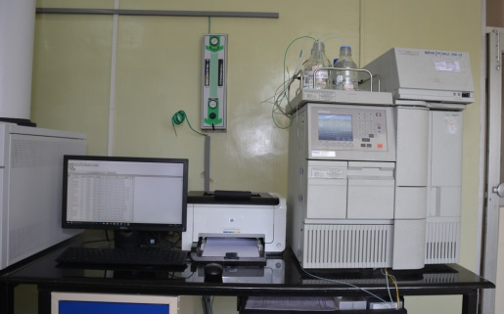  Existing Location: 304-III Floor  New Location: III Floor
 | GC-ECD  Make: Agilent Technologies  Model:7890A | 1 | 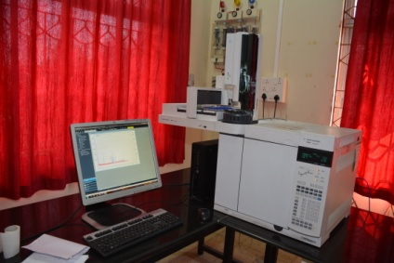  Existing Location: II Floor  New Location: II Floor
 | Muffle Furnace  Make: CINTEX  Model: - | 1 | 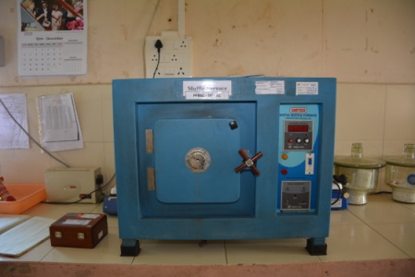  Existing Location: II Floor(Sample Prep. Room)  New Location: II Floor
 | Refrigerated Centrifuge  Make: REMI  Model: REMI C 24 BL | 2 | 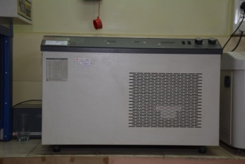  Existing Location: III Floor(Sample Prep. Room)  New Location: III Floor | Existing Location: II Floor(Sample Prep. Room)  New Location: II Floor
 | Refrigerated Centrifuge  Make: REMI  Model: REMI C 24 | 1 | 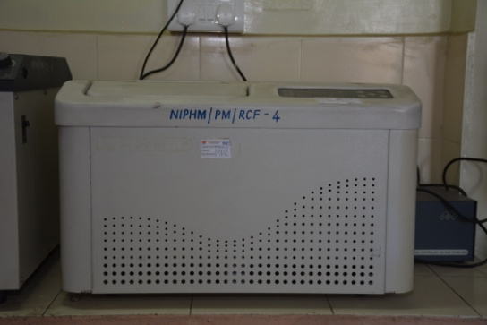  Existing Location: III Floor (Sample Prep. Room)  New Location: III Floor
 | Refrigerated Centrifuge  Make: REMI  Model: REMI C 23 | 1 | Existing Location: II Floor(Sample Prep. Room)  New Location: II Floor
 | Refrigerated Centrifuge  Make: Hermle  Model: Z326K | 2 | Existing Location: II Floor (Sample Prep. Room)  New Location: II Floor
 | Refrigerator  Make: Whirlpool  Model: DC2055S/2012 | 1 | Existing Location: II Floor (Sample Prep. Room)  New Location: II Floor
 | Refrigerator  Make: SAMSUNG  Model: R4524PAD 200722V | 1 | Existing Location: II Floor (Sample Prep. Room)  New Location: II Floor
 | Refrigerator  Make: SAMSUNG  Model: RT33FAR2ASP/TL/2013 | 1 | Existing Location: PT I Floor  New Location: PT I Floor
 | Rotary Evaporator  Make: IKA  Model: RV10DS96 | 1 | 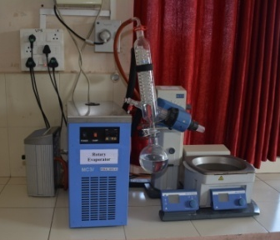  Existing Location: II Floor(Sample Prep. Room)  New Location: II Floor
 | Spectrophotometer-UV-Vis  Make: Shimadzu  Model: UV-2600 240V EN | 2 | Existing Location: II Floor (1 No.); I floor (1 No.)  New Location: II Floor (1 No.); I floor (1 No.)
 | Weighing Balance (3Kg)  Make: Sartorius  Model: BSA 3202S – CW | 1 | Existing Location: PFA I Floor  New Location: I Floor
 | Water Purification System  Make: Venchal  Model: Expe-CBUV90-M | 1 | 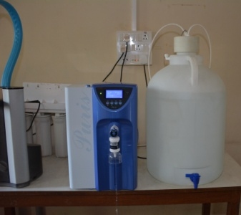  Existing Location: II Floor  New Location: II Floor
 | Water Purification System  Make: Elga  Model: PP00012480 | 1 | 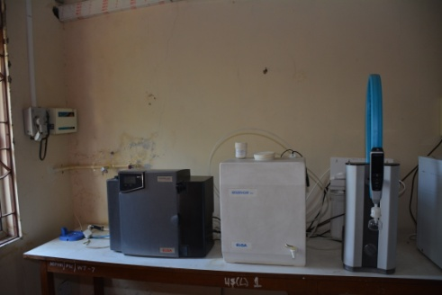  Existing Location: II Floor  New Location: II Floor
 | GC-FID  Make : Perkin Elmer  Model: Clarus 500 | 1 | 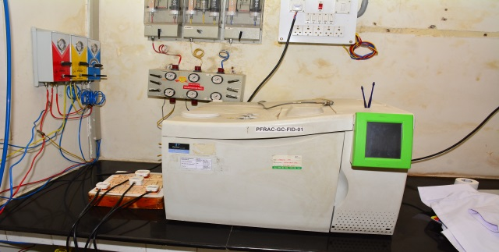  Existing Location: I Floor , PFA  New Location: IV Floor
 | FTIR  Make Perkin Elmer  Model: Spectrum 2 | 1 | Existing Location: I Floor , PFA  New Location: IV Floor
 | HPLC -UV-VIS  Make: Perkin Elmer  Model: Series 200 | 1 | 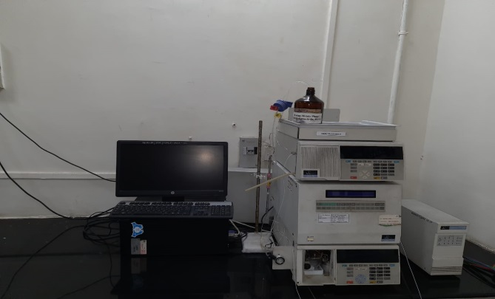  Existing Location: I Floor , PFA  New Location: IV Floor
 | GC-FID  Make: Agilent  Model: 7890 B | 1 | 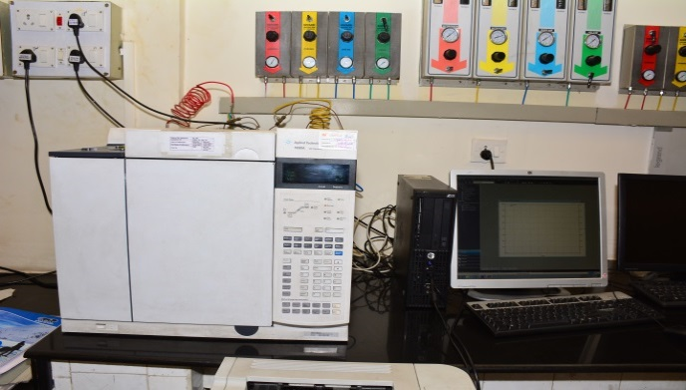  Existing Location: I Floor , PFA  New Location: IV Floor
 | GC-FID  Make: Agilent  Model: 7890 A | 1 | 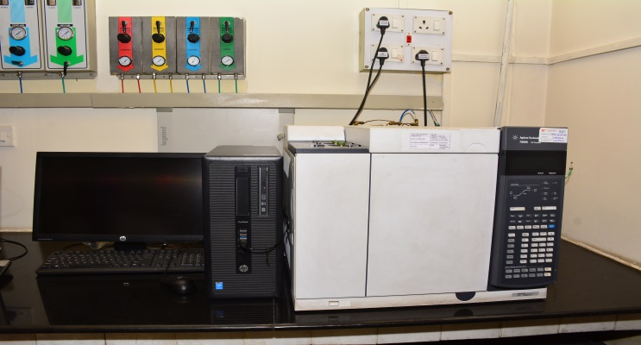  Existing Location: I Floor , PFA  New Location: IV Floor
 | HPLC -UV-VIS  Make: Waters  Model:2489 | 1 | 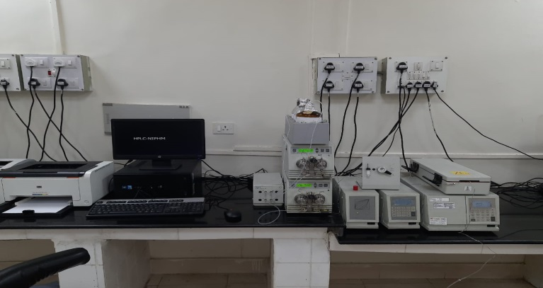  Existing Location: I Floor , PFA  New Location: IV Floor
 | HPLC -UV-VIS  Make: Shimadzu  Model: Prominence Bin | 1 | 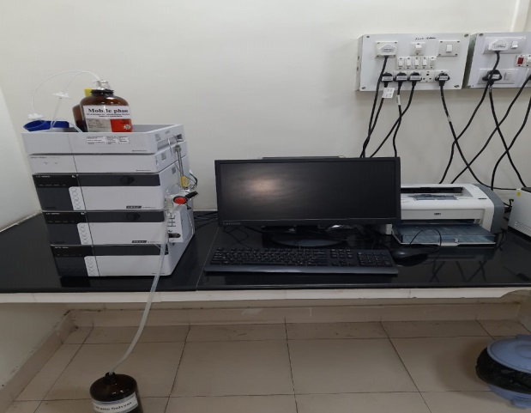  Existing Location: I Floor, PFA  New Location: IV Floor
 | Spectrophotometer UV-VIS  Make: Agilent  Model: Carry 100 UV-VIS | 1 | 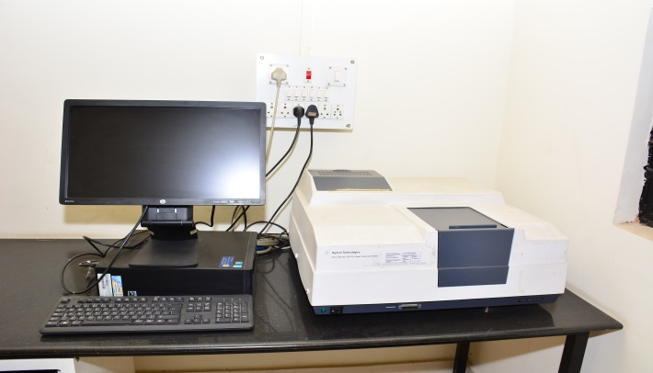  Existing Location: I Floor , PFA  New Location: IV Floor
 | Spectrophotometer UV-VIS  Make: Shimadzu  Model: UV-2600 240V EN | 1 | Existing Location: I Floor , PFA  New Location: IV Floor
 | Deep Freezer  Make: Venchal Scientific  Model:R-23 |  | 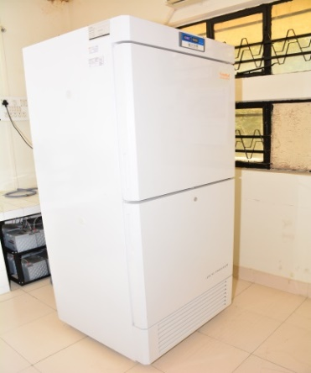  Existing Location: I Floor , PFA  New Location: IV Floor
 | Refrigerator  Make: Godrej  Model:Pentacool |  | 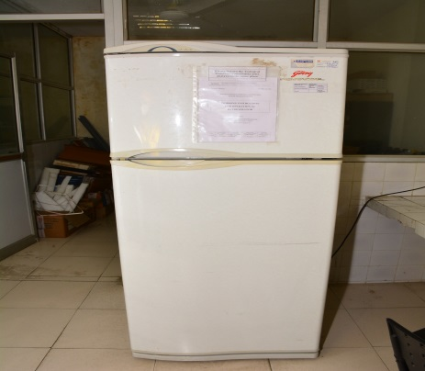  Existing Location: I Floor , PFA  New Location: IV Floor
 | UPS  Make & Model: CYBER UPS  Capacity: 7.5 KVA | 1 | 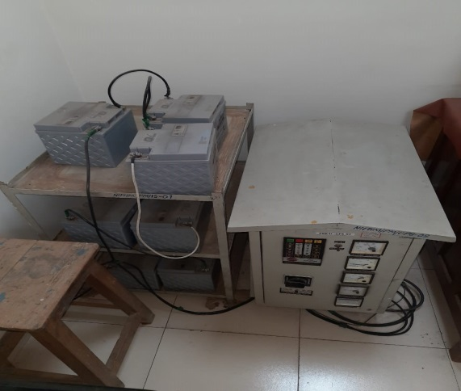  Existing Location: I Floor , PFA  New Location: IV Floor
 | UPS  Make & Model: ENERTECH ELECTRONICS  Capacity: 5 KVA | 1 | 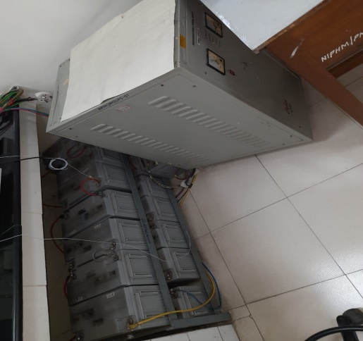  Existing Location: I Floor , PFA  New Location: IV Floor
 | UPS  Make: EMERSON S410D  Model: 10 KVA | 1 | 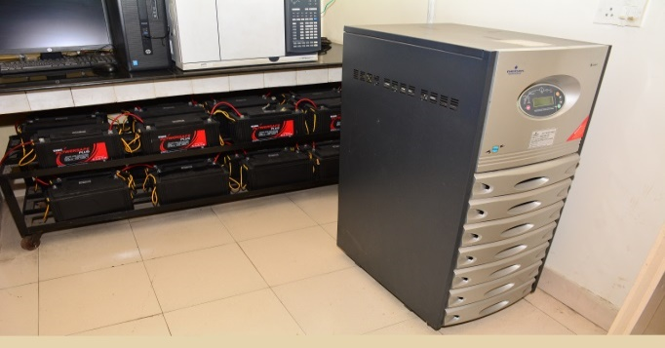  Existing Location: I Floor , PFA  New Location: IV Floor
 | UPS  Make: ONFINITI 5KVA FMIC, Numeric  Model: 5 KVA | 1 | 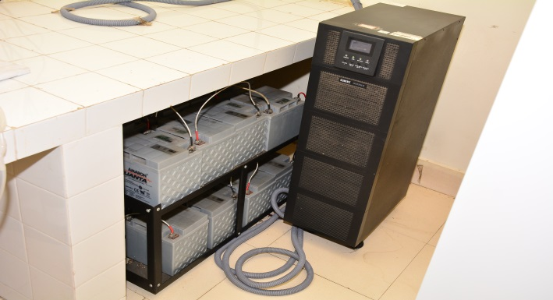  Existing Location: I Floor , PFA  New Location: IV Floor
 | UPS  Make: ELGI AIRMATE HLD-10  Model: 10 KVA | 1 | Existing Location: I Floor , PFA  New Location: IV Floor
 | Hot air Oven  Make: Lead Instrument  Model: LI – HAO | 2 | 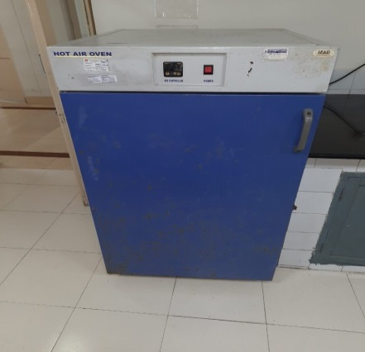  Existing Location: I Floor , PFA  New Location: IV Floor
Table: A (b) List of assets and equipment’s to be relocated (NOT to be calibrated)
Sr. No. | Name of Equipment (Make and Model) | No. of Equipment | Image of the equipment  (Details of Existing Location & New Location)
 | GCMSMS  Make: Agilent Technologies Ltd. Model: GC-7890 MS 7000 | 2 | 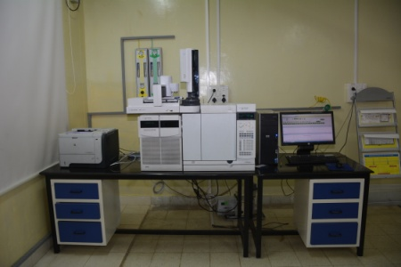 Existing Location: 305 -III floor  New Location: III floor | 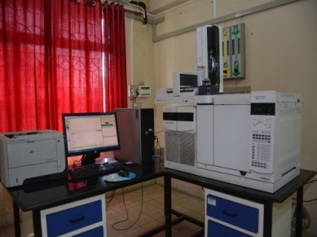  Existing Location: II floor  New Location: II floor
 | GC-Q-ToF  Make: Agilent Technologies Ltd.  Model: Agilent CN | 1 | Existing Location: 305-III Floor  New Location: III Floor
 | ICP-OES  Make: Agilent  Model: Agilent 5100 VDV | 1 | Existing Location: 303- III Floor  New Location: I Floor
 | LCMSMS  Make: Waters  Model: Acquity UPLC | 2 | Existing Location: 304-III Floor  New Location: III Floor | Existing Location: II Floor  New Location: II Floor
 | LC-Q-ToF  Make: Agilent  Model: Agilent SG | 1 | 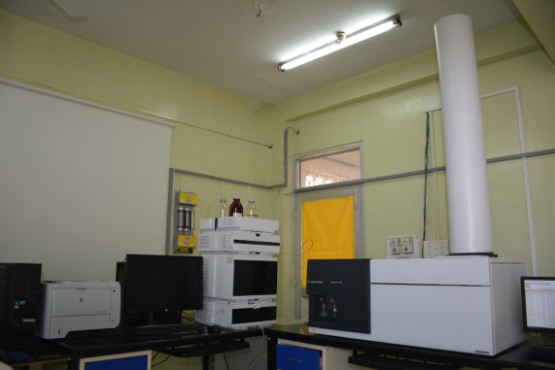  Existing Location: 304-III Floor  New Location: III Floor

Table: B (To be shifted with Soft Packing) (No Benchmarking/No Calibration)
S. no. | Items | Number | Image of the equipment  (Details of Existing Location & New Location)
 | Almarah with Glass door | 10 | Existing Location: I floor (3No.)  New Location: I floor | Existing Location: II floor (3 No.)  New Location: II floor |  |  | Existing Location: III floor (4 No.)  New Location:  III floor
 | Chemical Bottles /Glass Item | 50 | 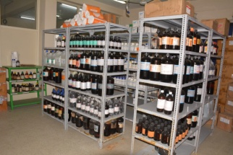Existing Location: I Floor PT (20 No.)  New Location: I Floor | 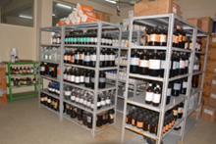  Existing Location: II floor (15No.)  New Location: II floor |  |  |  |  | Existing Location: III floor (15 No.)  New Location:  III floor
 | Chemical Bottles Boxes | 10 | Existing Location: I Floor PT (5 No.)  New Location: I Floor |  |  | Existing Location: III floor (5 No.)  New Location: III floor
 | Chemical Bottles Boxes | 20 | Existing Location: I Floor PT (10 No.)  New Location: I Floor |  |  | 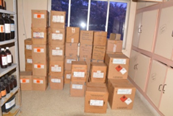 Existing Location: III floor (10 No.)  New Location: III floor
 | Gas Compressor | 1 | 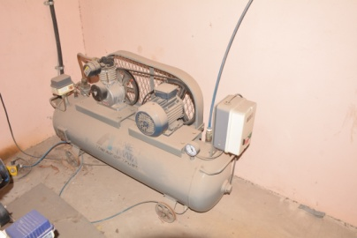  Existing Location: Ground Floor  New Location:
 | Glass ware & Bottles | 12 | 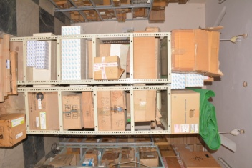  Existing Location: III Floor  New Location: III Floor
 | Homogenizer 6.5-8 Kg | 3 | Existing Location: II Floor (2 No. Sample Prep. Room); III Floor (1 No.)  New Location: II Floor & III floor
 | Homogenizer 23 L | 1 | 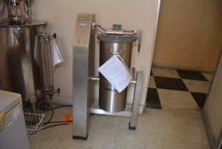  Existing Location: PT I Floor  New Location: PT I Floor
 | Homogenizer 165 L | 1 | 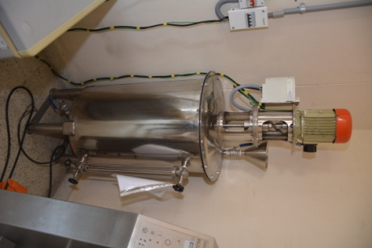  Existing Location: PT I Floor  New Location: PT I Floor
 | Mechanical Shaker | 1 | 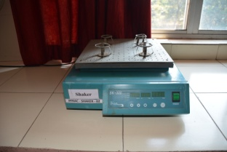  Existing Location: II Floor Sample Prep. Room  New Location: II Floor
 | UPS – 20 KVA | 3 | Existing Location: III Floor  New Location: III Floor
 | UPS – 10 KVA | 9 | 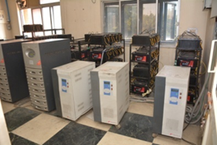  Existing Location: II Floor  (4 No.)  New Location: II Floor |  | 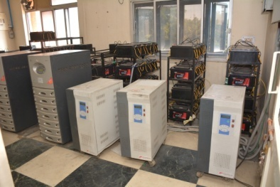 Existing Location: I Floor(1 No.)  New Location: I Floor |  |  | Existing Location: III Floor(4 No.)  New Location: III Floor
 | UPS - 5 KVA | 1 | 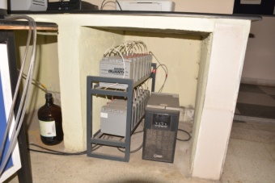  Existing Location: II Floor  New Location: II Floor

Table C:- Items to be Shifted (No Benchmarking/No Calibration)
S. no | Items | Number | Image of the equipment  (Details of Existing Location & New Location)
 | Alamirah | 10 | 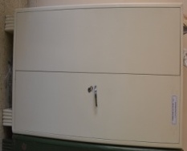  Existing Location: I Floor  (3 No.)  New Location: I Floor | Existing Location: II Floor  (3 No.)  New Location: II Floor |  | Existing Location: III Floor  (4 No.)  New Location: III Floor
 | UPS Batteries | 373 | Existing Location: I floor (48 No.)  New Location: : I floor | 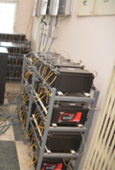 Existing Location: II floor (96 No.)  New Location: : II floor |  | Existing Location: III floor (229 No.)  New Location: : III floor
 | UPS Battery stand | 17 | Existing Location: I floor (3 No.)  New Location: : I floor | Existing Location: II floor (5 No.)  New Location: : II floor |  | Existing Location: III floor (9 No.)  New Location: : III floor
 | UPS Battery | 106 | Existing Location: I floor (PFA), 5 UPS  New Location: : IV floor
 | UPS Battery stand | 5 | Existing Location: I floor (PFA)  New Location: : IV floor
 | Analytical Gas Cylinders | 36 | 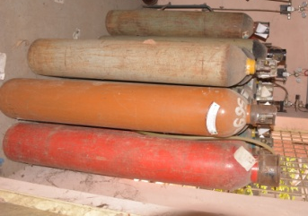  Existing Location: gas room  New Location: gas room
 | File rack | 11 | 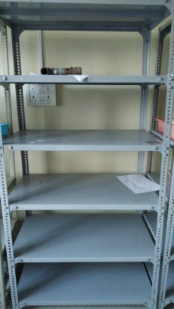  Existing Location: I floor (3 No.)  New Location: : I floor | 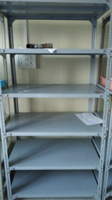 Existing Location: II floor (3 No.)  New Location: :II floor |  | Existing Location: III floor (5 No.)  New Location: : III floor
 | Gas Generator (Nitrogen-INEXUS) | 1 | 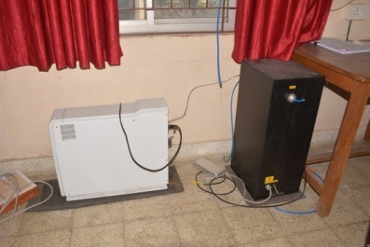  Existing Location: II Floor Report Prep. Room  New Location: II Floor
 | Gas Generator (PEAK- MSMS/ToF) | 4 | 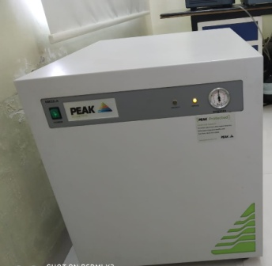  Existing Location: II Floor (1No.); III Floor (3 No.)  New Location: II Floor (1No.); III Floor (3 No.)
 | Sample Concentrator with Zero air Generator | 1 | 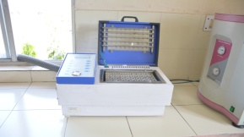  Existing Location: II Floor Sample Prep. Room  New Location: II Floor
 | Ro Water Unit With Drum | 1 | 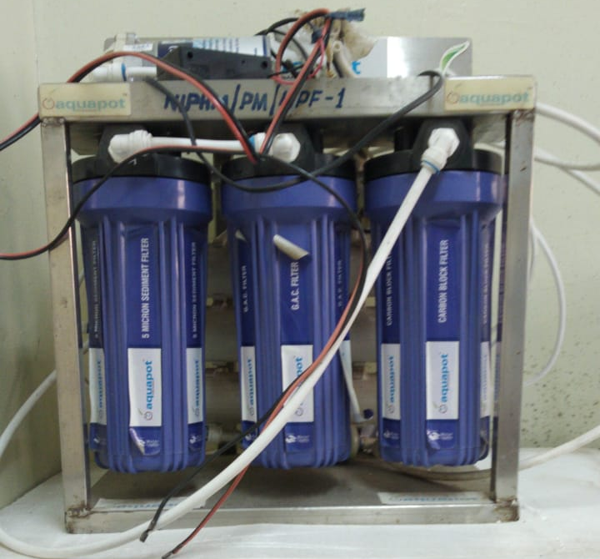  Existing Location: II Floor  New Location: II Floor
 | Iron racks for chemical storage | 15 | Existing Location: I floor (4 No.)  New Location: : I floor |  | Existing Location: II floor (2 No.)  New Location: II floor | Existing Location: III floor (9 No.)  New Location: : III floor

SECTION V. GENERAL CONDITIONS OF CONTRACT (GCC)

All the bidders are requested to please note that this document is available at www.niphm.gov.in where the details relating to the General Conditions of Contract of tender issued by the Stores Section of NIPHM is a part and parcel of the tender document for all Open Tender Enquiry (OTE) and Global Tender Enquiry (GTE). Consequently the individual OTE/GTEshall not contain this chapter called as General Conditions of Contract (GCC).

This General Conditions of Contract (GCC) shall be valid for all Open and Global tender Enquiry being issued by NIPHM and is valid till further notice.

CONDITIONS OF CONTRACT
Table of Contents

Sl. No. | Clause
 | Definitions
 | Contract Documents
 | Code of Integrity
 | Joint Venture, Consortium or Association
 | Scope of Supply
 | Suppliers’ Responsibilities
 | Contract price
 | Copy Right
 | Application
 | Standards
 | Use of Contract Documents and Information
 | Patent Indemnity
 | Performance Security
 | Inspections and Tests
 | Packing
 | Delivery and Documents
 | Indemnifying against damages to person, property & status
 | Transportation
 | Incidental Services
 | Spare Parts
 | Warranty
 | Change Orders and Contract Amendments
 | Assignment
 | Subcontracts
 | Extension of time
 | Liquidated Damages
 | Termination for Default
 | Force Majeure
 | Termination for insolvency
 | Termination for Convenience
 | Settlement of Disputes
 | Governing Language
 | Applicable Law
 | Notice
 | Taxes and Duties
 | Right to use Defective Goods
 | Site preparation and installation
 | Import and Export Licenses
 | Risk Purchase Clause
 | Option Clause
 | Integrity Pact
 | Order Acceptance
 | Execution of Agreement
 | Evaluation and Comparison of Bids
 | 'Public Procurement (Preference to Make in India), Order 2017" dated 16.09.2020 effective with immediate effect.
 | Clarifications in the Tender
 | Amendments to the Tender
 | Modification and Withdrawal of Bids
 | Conflict of Interest among Bidders/Agents
 | Quotation received from Dealers / Agents for items not manufactured by them
 | Examination of Bids and Determination of Responsiveness
 | Correction of Errors:
 | Contacting the Purchaser
 | Award of Contract
 | Award Criteria
 | Notification of Award
 | Signing of Contract
 | General Instructions
 | Signing of Bids
 | Acceptance of Tender / Conditions of the Contract
 | Rates and Prices
 | Country of Origin
 | Documents to be submitted to Consignee at the time of delivery of Goods
 | Terms of Payment
 | Delays in the Supplier’s Performance

- Definitions:
In this Contract, the following terms shall be interpreted as indicated:-
- “The Contract” means the agreement entered into between the Purchaser and the Supplier, as recorded in the Contract Form signed by the parties, including all the attachments and appendices thereto and all documents incorporated by reference therein;
- “The Contract Price” means the price payable to the Supplier under the Contract for the full and proper performance of its contractual obligations;
- “The Goods” means all the equipment, machinery, and/or other materials, which the Supplier is required to supply to the Purchaser under the Contract;
- “The Services” means those services ancillary to the supply of the Goods, such as transportation and insurance, and any other incidental services, such as installation, commissioning, provision of technical assistance, training and other obligations of the Supplier covered under the Contract;
- “ITB” means Instructions to Bidders;
- “GCC” means the General Conditions of Contract contained in this section;
- “SCC” means the Special Conditions of Contract contained in ITB;
- “Consignee” means the person to whom the Goods are required to be delivered and final acceptance certificate to be issue on behalf of Purchaser.
- “The Purchaser” means the Organization purchasing the Goods “National Institute of Plant Health Management, Ministry of Agriculture& Farmer’s Welfare, Govt of India, Hyderabad”.
- “The Supplier” means the individual or firm supplying the Goods under this Contract;
- “Effective date” of contract shall mean the date of Notice of Award.
- “Government” means Government of India.

- Contract Documents
Subject to the order of precedence set forth in the Contract Agreement, all documents forming the Contract (and all parts thereof) are intended to be correlative, complementary, and mutually explanatory. The Contract Agreement shall be read as a whole.

- Code of Integrity
Without prejudice to and in addition to the rights of the Purchaser to other penal provisions, as per the bid documents or contract, if the Purchaser comes to a conclusion that a (prospective) bidder/supplier, directly or through an agent, has violated this code of integrity in competing for the contract or in executing a contract, the Purchaser may take appropriate measures including one or more of the following:

a) Cancellation of the relevant contract and recovery of compensation for loss incurred by the purchaser;

b) Forfeiture or encashment of any other security or bond relating to the procurement;

c) Recovery of payments including advance payments, if any, made by the Purchaser along with interest thereon, at the prevailing rate.

Provisions in addition to above:

1) Removal from the list of registered suppliers and banning/debarment of the bidder from participation in future procurements of the purchaser for a period not less than one year;

2) In case of anti-competitive practices, information for further processing may be filed under a signature of the Joint Secretary level officer, with the Competition Commission of India;
3) Initiation of suitable disciplinary or criminal proceedings against any individual or staff found responsible.

- Joint Venture, Consortium or Association
If the Supplier is a joint venture, consortium, or association, all of the parties shall be jointly and severally liable to the Purchaser for the fulfilment of the provisions of the Contract and shall designate one party to act as a leader with authority to bind the joint venture, consortium, or association. The composition or the constitution of the joint venture, consortium, or association shall not be altered without the prior consent of the Purchaser.

- Scope of Supply
The specifications and allied technical details of the Goods and Related Services to be supplied shall be as specified in NIT document.

- Suppliers’ Responsibilities
The Supplier shall supply all the Goods and Related Services included in the Scope of Supply in accordance with Scope of Supply Clause of the GCC, and the Delivery and Completion Schedule, as per GCC Clause relating to delivery and document.

- Contract price
Prices charged by the Supplier for the Goods supplied and the Related Services performed under the Contract shall not vary from the prices quoted by the Supplier in its bid.

- Copy Right
The copyright in all drawings, documents, and other materials containing data and information furnished to the Purchaser by the Supplier herein shall remain vested in the Supplier, or, if they are furnished to the Purchaser directly or through the Supplier by any third party, including suppliers of materials, the copyright in such materials shall remain vested in such third party.

- Application
These General Conditions shall apply to the extent that they are not superseded by provisions in other parts of the Contract.

- Standards
The Goods supplied and services rendered under this Contract shall conform to the standards mentioned in the Technical Specifications, and, when no applicable standard is mentioned, to the authoritative standard appropriate to the Goods' country of origin and such standards shall be the latest issued by the concerned institution.

- Use of Contract Documents and Information
The Supplier shall not, without the Purchaser's prior written consent, disclose the Contract, or any provision thereof, or any specification, plan, drawing, pattern, sample or information furnished by or on behalf of the Purchaser in connection therewith, to any person other than a person employed by the Supplier in performance of the Contract. Disclosure to any such employed person shall be made in confidence and shall extend only so far, as may be necessary for purposes of such performance.

The Supplier shall not, without the Purchaser's prior written consent, make use of any document or information enumerated above except for purposes of performing the Contract.

Any document, other than the Contract itself, enumerated above shall remain the property of the Purchaser and shall be returned (in all copies) to the Purchaser on completion of the Supplier's performance under the Contract if so required by the Purchaser

- Patent Indemnity
- The Supplier shall, subject to the Purchaser’s compliance with GCC Sub-Clause 12 (3) indemnify and hold harmless the Purchaser and its employees and officers from and against any and all suits, actions or administrative proceedings, claims, demands, losses, damages, costs, and expenses of any nature, including attorney’s fees and expenses, which the Purchaser may suffer as a result of any infringement or alleged infringement of any patent, utility model, registered design, trademark, copyright, or other intellectual property right registered or otherwise existing at the date of the Contract by reason of:

  - the installation of the Goods by the Supplier or the use of the Goods in India; and
  - the sale in any country of the products produced by the Goods.
  - If any proceedings are brought or any claim is made against the Purchaser, the Purchaser shall promptly give the Supplier a notice thereof, and the Supplier may at its own expense and in the Purchaser’s name conduct such proceedings or claim and any negotiations for the settlement of any such proceedings or claim.

- Performance Security (PS)
- Within 10 days of receipt of the notification of award/PO, the Supplier shall furnish performance security as specified in NIT and should remain valid for a period of sixty (60) days beyond all contractual obligations of the supplier including warranty obligation.
- The proceeds of the performance security shall be payable to the Purchaser as compensation for any loss resulting from the Supplier's failure to complete its obligations under the Contract.
- The Performance Security shall be denominated in Indian Rupees for the offers received for supplies within India and denominated in the currency of the contract in the case of offers received for supply from foreign countries or in equivalent Indian Rupees in case the Performance Security is submitted by the Indian Agent.
- In the case of imports, the PS may be submitted either by the principal or by the Indian agent and, in the case of purchases from indigenous sources, the PS may be submitted by either the manufacturer or their authorized dealer/bidder.

The Performance security shall be in one of the following forms:
- A Bank guarantee or stand-by Letter of Credit issued by a Nationalized/Scheduled bank located in India or a bank located abroad in the form provided in the bidding documents.
Or
- A Banker’s cheque or Account Payee demand draft in favour of the purchaser.
Or
- A Fixed Deposit Receipt from a commercial bank pledged in favour of the Purchaser.
- The performance security will be discharged by the Purchaser and returned to the Supplier not later than 60 days following the date of completion of the Supplier's performance obligations, including any warranty obligations, unless specified otherwise in SCC, without levy of any interest.
- In the event of any contract amendment, the supplier shall, within 21 days of receipt of such amendment, furnish the amendment to the performance security, rendering the same valid for the duration of the contract, as amended for further period of 60 days thereafter.
- The order confirmation must be received within 7 days. However, the Purchaser has the powers to extend the time frame for submission of order confirmation and submission of Performance Security (PS). Even after extension of time, if the order confirmation /PS are not received, the purchaser, on being satisfied that it is not a case of cartelization and the integrity of the procurement process has been maintained, may, for cogent reasons, the contract shall be cancelled.
- Whenever, the bidder chooses to submit the Performance Security in the form of Bank Guarantee, then he should advise the banker issuing the Bank Guarantee to immediately send by Registered Post (A.D.) an unstamped duplicate copy of the Guarantee directly to the Purchaser with a covering letter to compare with the original BG for the correctness, genuineness, etc.

- Inspections and Tests
The inspections & test, training required would be conducted by the seller, wherever required with no additional costs or as detailed in SCC of bidding document.

- Packing
The Supplier shall provide such packing of the Goods as is required to prevent their damage or deterioration during transit to their final destination as indicated in the Contract. The packing shall be sufficient to withstand, without limitation, rough handling during transit and exposure to extreme temperatures, salt and precipitation during transit and open storage. Packing case size and weights shall take into consideration, where appropriate, the remoteness of the Goods' final destination and the absence of heavy handling facilities at all points in transit.

The packing, marking and documentation within and outside the packages shall comply strictly with such special requirements as shall be provided for in the Contract including additional requirements, if any, specified in SCC and in any subsequent instructions ordered by the Purchaser.

- Delivery and Documents
Delivery of the Goods and completion and related services shall be made by the supplier in accordance with the terms specified by the Purchaser in the contract. The details of shipping and/or other documents to be furnished by the supplier are specified in SCC.

The terms FOB, FCA, CIF, CIP, etc. shall be governed by the rules prescribed in the current edition of the Inco terms published by the International Chambers of Commerce, Paris.
The mode of transportation shall be as specified in SCC. In case the purchaser elects to have the transportation done through Air, then air lifting needs to be done through Air India only. In case Air India does not operate in the Airport of despatch, then the bidder is free to engage the services of any other Airlines.

- Insurance:
Should the purchaser elect to buy on CIF/CIP basis, the Goods supplied under the Contract shall be fully insured against any loss or damage incidental to manufacture or acquisition, transportation, storage and delivery in the manner specified in SCC.

Where delivery of the goods is required by the purchaser on CIF or CIP basis the supplier shall arrange and pay for Cargo Insurance, naming the purchaser as beneficiary and initiate & pursue claims till settlement, on the event of any loss or damage.

Where delivery is on FOB or FCA basis, insurance would be the responsibility of the purchaser.

With a view to ensure that claims on insurance companies, if any, are lodged in time, the bidders and /or the Indian agent shall be responsible for follow up with their principals for ascertaining the dispatch details and informing the same to the Purchaser and he shall also liaise with the Purchaser to ascertain the arrival of the consignment after clearance so that immediately thereafter in his presence the consignment could be opened and the insurance claim be lodged, if required, without any loss of time. Any delay on the part of the bidder/Indian Agent would be viewed seriously and he shall be directly responsible for any loss sustained by the purchaser on the event of the delay.

NIPHM is not insisting any insurance. It is the prorogation of the bidder and NIPHM is not going to give any declared value. However, L1 bidder may go for Insurance to protect their interest.

- Indemnifying against damages to Persons, Property & Status
- The contractor shall take all precautions to avoid all accidents by exhibiting necessary caution boards day and night, speed limit boards, red flags, red lights and providing barriers. He shall be responsible for all damages and accidents caused due to negligence on his part. No hindrance shall be caused to traffic during the execution of work.
- The contractor shall be responsible for ail injury to persons, animals or things, and for all damage, whether such injury or damage arises from carelessness or accident in any way connected therewith. This clause shall be he'd to include interalia any damage due to causes as aforesaid to work, building (whether immediately adjacent or otherwise) and to roads, streets, foot paths, bridges or ways as well as all damage caused to the buildings and works forming the subject of this contract by inclemency of weather. The contractor indemnifies the Employer and holds him harmless in respect of ail expenses arising from such injury or damages as aforesaid and also in respect of any award of compensation or damage consequent upon such claim including legal costs.
- The contractor shall reinstate all damage of every sort mentioned in this clause, so as to deliver the whole of the contracted works complete and perfect in every respect and so as to make good and otherwise satisfy all claims for damage as aforesaid to the property of third parties.
- The contractor also indemnifies the Employer against all claim which may be made upon the Employer for acts during the currency of this contract by any employee or representative of an employee of the contractor or any sub-contractors, employed by him, for any injury to or loss of life, of such employees, or for compensation payable under any law for the time being in force to any workmen or to the representative of arty deceased or incapacitated workmen.
- The contractor also indemnifies the Employer against all claims which may be made upon the Employer for acts during the currency of this contract by the Central/State Government or local Municipal authorities for the non Compliance of any laws, regulations, rules pertaining to wages act, safety act in force and any amendments thereof in respect of all labour and apprentices directly or indirectly employed in the work Under this contract.
- The Employer shall be at liberty and is hereby empowered to deduct the amount of any damages, compensation cost, charges and/or expenses arising or accruing from or in respect of any such claim and / or damages as aforesaid from any sum or sums due or to become due to the contractor or security deposit.
- The contractor shall indemnify the Employer against any action, claim or proceedings relating to infringement or use of any patent or design or any alleged patent or design rights and shall pay any royalties which may be payable in respect of any article or part thereof included in the contract. In the event of any claims made under or action brought against the Employer in respect of any such matters as aforesaid the contractor shall be immediately notified thereof and the contractor shall be at liberty, at his own expense, to settle any dispute or to conduct any litigation that may arise therefrom. Provided that the contractor shall not be liable to indemnify the Employer if the infringement of the patent or design or any alleged patent or design right is the direct result of an order passed by the said Employer or his authorized representative.

- Transportation
Where the Supplier is required under the Contract to deliver the Goods FOB, transport of the Goods, up to and including the point of putting the Goods on board the vessel at the specified port of loading, shall be arranged and paid for by the Supplier, and the cost thereof shall be included in the Contract price. Where the Supplier is required under the Contract to deliver the Goods FCA, transport of the Goods and delivery into the custody of the carrier at the place named by the Purchaser or other agreed point shall be arranged and paid for by the Supplier, and the cost thereof shall be included in the Contract Price.

Where the Supplier is required under the Contract to deliver the Goods CIF or CIP, transport of the Goods to the port of destination or such other named place of destination in the Purchaser’s country, as shall be specified in the Contract, shall be arranged and paid for by the Supplier, and the cost thereof shall be included in the Contract Price.

In the case of supplies from within India, where the Supplier is required under the Contract to transport the Goods to a specified destination in India, defined as the Final Destination, transport to such destination, including insurance and storage, as specified in the Contract, shall be arranged by the Supplier, and the related costs shall be included in the Contract Price.

- Incidental Services
The supplier may be required to provide any or all of the services, including training, if any, specified in the Tender.

- Spare Parts
The Supplier shall be required to provide any or all of the following materials, notifications, and information pertaining to spare parts manufactured or distributed by the Supplier:

(a) Such spare parts as the Purchaser may elect to purchase from the Supplier, providing that this election shall not relieve the Supplier of any warranty obligations under the Contract; and

(b) In the event of termination of production of the spare parts:

(i) Advance notification to the Purchaser of the pending termination, in sufficient time to permit the Purchaser to procure needed requirements; and

(ii) Following such termination, furnishing at no cost to the Purchaser, the blueprints, drawings and specifications of the spare parts, if requested.

- Warranty
The Supplier warrants that all the Goods are new, unused, and of the most recent or current models, and that they incorporate all recent improvements in design and materials, unless provided otherwise in the Contract.

The Supplier further warrants that the Goods shall be free from defects arising from any act or omission of the Supplier or arising from design, materials, and workmanship, under normal use in the conditions prevailing in India.

Unless otherwise specified in the SCC, the warranty shall remain valid for Twelve (12) months after the Goods, or any portion thereof as the case may be, have been delivered to and accepted at the final destination indicated in the SCC, or for Eighteen (18) months after the date of shipment from the port or place of loading in the country of origin, whichever period concludes earlier.

The Purchaser shall give notice to the Supplier stating the nature of any such defects together with all available evidence thereof, promptly following the discovery thereof.
The Purchaser shall afford all reasonable opportunity for the Supplier to inspect such defects.

Upon receipt of such notice, the Supplier shall, within a reasonable period of time, expeditiously repair or replace the defective Goods or parts thereof, at no cost to the Purchaser.

If having been notified, the Supplier fails to remedy the defect within a reasonable period of time; the Purchaser may proceed to take within a reasonable period such remedial action as may be necessary, at the Supplier’s risk and expense and without prejudice to any other rights which the Purchaser may have against the Supplier under the Contract.

Goods requiring warranty replacements must be replaced on free of cost basis to the purchaser.

- Change Orders and Contract Amendments
The Purchaser may at any time, by written order given to the Supplier pursuant to Clause on Notices of the GCC make changes within the general scope of the Contract in any one or more of the following:
(a) Increase or decrease in the quantity required, exercise of quantity opinion clause;
(b) Changes in schedule of deliveries and terms of delivery;
(c) The changes in inspection arrangements;
(d) Changes in terms of payments and statutory levies;
(e) Changes due to any other situation not anticipated;

No changes in the price quoted shall be permitted after the purchase order has been issued except on account of statutory variations.

No variation or modification in the terms of the contract shall be made except by written amendment signed by the parties.

- Assignment
The Supplier shall not assign, in whole or in part, its obligations to perform under the Contract, except with the Purchaser's prior written consent.

- Subcontracts
The Supplier shall notify the Purchaser in writing of all subcontracts awarded under this Contract if not already specified in the bid. Such notification, in the original bid or later, shall not relieve the Supplier from any liability or duties or obligation under the contract.

- Extension of time.
Delivery of the Goods and performance of the Services shall be made by the Supplier in accordance with the time schedule specified by the Purchaser.

If at any time during performance of the Contract, the Supplier or its sub-contractor(s) should encounter conditions impeding timely delivery of the Goods and performance of Services, the Supplier shall promptly notify the Purchaser in writing of the fact of the delay, its likely duration and its cause(s). As soon as practicable after receipt of the Supplier’s notice, the Purchaser shall evaluate the situation and may, at its discretion, extend the Supplier’s time for performance with or without liquidated damages, in which case the extension shall be ratified by the parties by amendment of the Contract.

Except as provided under the Force Majeure clause of the GCC, a delay by the Supplier in the performance of its delivery obligations shall render the Supplier liable to the imposition of liquidated damages pursuant to liquidated damages Clause of the GCC unless an extension of time is agreed upon pursuant to above clause without the application of penalty clause.

- Liquidated Damages
Subject to GCC Clause on Force Majeure, if the Supplier fails to deliver any or all of the Goods or to perform the Services within the period(s) specified in the Contract, the Purchaser shall, without prejudice to its other remedies under the Contract, deduct from the Contract Price, as penalty, a sum equivalent to the 0.5 percentage (%) of the delivered price of the delayed Goods or unperformed Services or contract value in case the delivered price of the delayed goods or unperformed services cannot be ascertained from the contract, for each week/per day, (as mentioned in SCC) or part thereof of delay until actual delivery or performance, up to a maximum deduction of the 10% Percentage. Once the maximum is reached, the Purchaser may consider termination of the Contract pursuant to GCC Clause on Termination for Default.

- Termination for Default
The Purchaser may, without prejudice to any other remedy for breach of contract, by written notice of default sent to the Supplier, terminate the Contract in whole or part

(a) If the Supplier fails to deliver any or all of the Goods within the period(s) specified in the contract, or within any extension thereof granted by the Purchaser pursuant to GCC Clause on Extension of Time; or
(b) If the Supplier fails to perform any other obligation(s) under the Contract.
(c) If the Supplier, in the judgment of the Purchaser has engaged in corrupt or fraudulent or collusive or coercive practices etc as defined in GCC Clause and ITB clause on code of integrity in competing for or in executing the Contract.

In the event the purchaser terminates the contract in whole or in part, he may take recourse to any one or more of the following action:

(a) The Performance Security is to be forfeited;
(b) The purchaser may procure, upon such terms and in such manner as it deems appropriate, stores similar to those undelivered, and the supplier shall be liabe for all available actions against it in terms of the contract.
(c) However, the supplier shall continue to perform the contract to the extent not terminated.

- Force Majeure
Notwithstanding the provisions of GCC Clauses relating to extension of time, Liquidated damages and Termination for Default the Supplier shall not be liable for forfeiture of its performance security, liquidated damages or termination for default, if and to the extent that, its delay in performance or other failure to perform its obligations under the Contract is the result of an event of Force Majeure.

For purposes of this Clause, “Force Majeure” means an event or situation beyond the control of the Supplier that is not foreseeable, is unavoidable, and its origin is not due to negligence or lack of care on the part of the Supplier. Such events may include, but not be limited to, acts of the Purchaser in its sovereign capacity, wars or revolutions, fires, floods, epidemics, quarantine restrictions, and freight embargoes.

If a Force Majeure situation arises, the Supplier shall promptly notify the Purchaser in writing of such conditions and the cause thereof within 21 days of its occurrence. Unless otherwise directed by the Purchaser in writing, the Supplier shall continue to perform its obligations under the Contract as far as is reasonably practical, and shall seek all reasonable alternative means for performance not prevented by the Force Majeure event.

If the performance in whole or in part or any obligations under the contract is prevented or delayed by any reason of Force Majeure for a period exceeding 60 days, either party may at its option terminate the contract without any financial repercussions on either side.

- Termination for Insolvency
The Purchaser may at any time terminate the Contract by giving written notice to the Supplier, if the Supplier becomes bankrupt or otherwise insolvent. In this event, termination will be without compensation to the Supplier, provided that such termination will not prejudice or affect any right of action or remedy, which has accrued or will accrue thereafter to the Purchaser.

- Termination for Convenience
The Purchaser, by written notice sent to the Supplier, may terminate the Contract, in whole or in part, at any time. The notice of termination shall specify that termination is for the Purchaser's convenience, the extent to which performance of the Supplier under the Contract is terminated, and the date upon which such termination becomes effective.

The Goods that are complete and ready for shipment within 30 days after the Supplier's receipt of notice of termination shall be accepted by the Purchaser at the Contract terms and prices. For the remaining Goods, the Purchaser may elect:

(a) To have any portion completed and delivered at the Contract terms and prices; and/or
(b) To cancel the remainder and pay to the Supplier an agreed amount for partially completed Goods and for materials and parts previously procured by the Supplier.

- Settlement of Disputes
The Purchaser and the supplier shall make every effort to resolve amicably by direct informal negotiation any disagreement or dispute arising between them under or in connection with the Contract.

If, after twenty-one (21) days, the parties have failed to resolve their dispute or difference by such mutual consultation, then either the Purchaser or the Supplier may give notice to the other party of its intention to commence arbitration, as hereinafter provided, as to the matter in dispute, and no arbitration in respect of this matter may be commenced unless such notice is given. Any dispute or difference in respect of which a notice of intention to commence arbitration has been given in accordance with this Clause shall be finally settled by arbitration. Arbitration may be commenced prior to or after delivery of the Goods under the Contract.

The dispute settlement mechanism/arbitration proceedings shall be concluded as under:

(a) If any dispute or difference arises between the parties hereto as to the construction, interpretation, effect and implication of any provision of this agreement including the rights or liabilities or any claim or demand of any party against other or in regard to any other matter under these presents but excluding any matters, decisions or determination of which is expressly provided for in this Agreement, such disputes or differences shall be referred to an Arbitral Bench consisting of three Arbitrators, one each to be appointed by each party and the two Arbitrators shall appoint a third Arbitrator who shall be the presiding Arbitrator. A reference to the Arbitration under this Clause shall be deemed to be submission within the meaning of the Arbitration and Conciliation Act, 1996 and the rules framed thereunder for the time being in force. Each party shall bear and pay its own cost of the arbitration proceedings unless the Arbitrators otherwise decides in the Award.

(b) In the case of a dispute between the purchaser and a Foreign Supplier, the dispute shall be settled by arbitration in accordance with provision of sub-clause (a) above. But if this is not acceptable to the supplier then the dispute shall be settled in accordance with provisions of UNCITRAL (United Nations Commission on International Trade Law) Arbitration Rules.

The venue of the arbitration shall be the place from where the purchase order or contract is issued.
Notwithstanding, any reference to arbitration herein,

(a) The parties shall continue to perform their respective obligations under the Contract unless they otherwise agree; and

(b) the Purchaser shall pay the Supplier any monies due the Supplier.

- Governing Language
The contract shall be written in English language which shall govern its interpretation. All correspondence and other documents pertaining to the Contract, which are exchanged by the parties, shall be written in the English language only.

- Applicable Law
The Contract shall be interpreted in accordance with the laws of the Union of India and all disputes shall be subject to place of jurisdiction as specified in SCC.

- Notices
Any notice given by one party to the other pursuant to this contract/order shall be sent to the other party in writing or by cable, telex, FAX, e-mail or and confirmed in writing to the other party’s address specified in the SCC.

A notice shall be effective when delivered or on the notice’s effective date, whichever is later.

- Taxes and Duties
For goods manufactured outside India, the Supplier shall be entirely responsible for all taxes, stamp duties, license fees, and other such levies imposed outside India.

For goods Manufactured within India, the Supplier shall be entirely responsible for all taxes, duties, license fees, etc., incurred till its final manufacture/production.

If any tax exemptions, reductions, allowances or privileges may be available to the Supplier in India, the Purchaser shall make its best efforts to enable the Supplier to benefit from any such tax savings to the maximum allowable extent.

All payments due under the contract shall be paid after deduction of statutory levies (at source) (like IT, etc.) wherever applicable.

Customs Duty – If the supply is from abroad this Institute is permitted to import goods as per notification No.51/96 – Customs and pay a concessional duty up to 5% as per notification 24/2002 – Customs on all imports.

- Right to use Defective Goods
If after delivery, acceptance and installation and within the guarantee and warranty period, the operation or use of the goods proves to be unsatisfactory, the Purchaser shall have the right to continue to operate or use such goods until rectifications of defects, errors or omissions by repair or by partial or complete replacement is made without interfering with the Purchaser’s operation.

- Site preparation and installation
The Purchaser is solely responsible for the construction of the equipment sites in compliance with the technical and environmental specifications defined by the Supplier. The Purchaser will designate the installation sites before the scheduled installation date to allow the Supplier to perform a site inspection to verify the appropriateness of the sites before the installation of the Equipment, if required. The supplier shall inform the purchaser about the site preparation, if any, needed for installation, of the goods at the purchaser’s site immediately after notification of award/contract.

- Import and Export Licenses
If the ordered materials are covered under restricted category of EXIM policy in India the Vendor / Agent may intimate such information for obtaining necessary, license in India.

If the ordered equipment is subject to Vendor procuring an export license from the designated government agency / country from where the goods are shipped / sold, the vendor has to mention the name, address of the government agency / authority. The vendor must also mention the time period within which the license will be granted in normal course.

- Risk Purchase Clause
If the supplier fails to deliver the goods within the maximum delivery period specified in the contract or Purchase Order, the purchaser may procure, upon such terms and in such a manner as it deems appropriate, Goods or Services similar to those undelivered and the Supplier shall be liable to the purchaser for any excess costs incurred for such similar goods or services.

- Option Clause
The Purchaser reserves the right to increase or decrease the quantity of the required goods up to 25% (Twenty-Five) per cent at any time, till final delivery date (or the extended delivery date of the contract), by giving reasonable notice even though the quantity ordered initially has been supplied in full before the last date of the delivery period (or the extended delivery period)

- Integrity Pact
The SCC shall specify whether there is a need to enter into a separate Integrity pact or not. The names and contact details of the Independent External Monitors (IEM) on the event of the need of IP is as detailed in the SCC. (Annexure-I)

- Order Acceptance
The successful bidder should submit Order acceptance within 7 days from the date of issue of order/signing of contract, failing which it shall be presumed that the vendor is not interested and his bid security is liable to be forfeited.

- Execution of Agreement:
- The successful Bidder is required to execute enter into an Agreement on non-judicial stamp paper of Rs.100/- for fulfilment of the contract. Along with the Agreement the required Security Deposit shall be remitted.
- The successful Bidders shall not assign or make over the contract, the benefit or burden thereof to any other person or persons or Body Corporate for the execution of the contract or any part thereof.

- Evaluation and Comparison of Bids
- Bidders will be eligible for further processing only if they fulfil the following criteria
- Compliance with the eligibility Criteria.
- Compliance with Technical and capacity requirements.
- NIPHM will prepare a list of Bidders whose bids are substantially responsive with the technical and capacity requirements as given in Tender form. The Tenders which do not match eligibility criteria or which do not conform substantially to the Technical Specifications shall be rejected. The Eligible bidders alone will be considered for further evaluation.
- The contract shall be awarded only to the bidder who are substantially responsive, offer competitive rates, and meet the qualification requirement stipulated in the bidding documents.
- Deviations in the delivery schedule and Payment schedule are not permitted.
- In exercising of the powers conferred in Section 11 of the Micro, Small and Medium Enterprises Development (MSMED) Act 2006, the Government has notified a new Public Procurement Policy for Micro & Small Enterprises effective from 23rd March, 2012 and subsequent order dated 9th November, 2018.

In accordance to the above notifications, in tenders, where the L1 (evaluated price) bidder is a non-MSE, up to 25% of the tendered quantity shall be allowed to be supplied by participating MSEs provided that the tendered quantity is divisible into two or more orders and adequate for the purpose; all qualifying bidders have agreed for acceptance of part-order quantity and participating MSE matches the L1 rate. A share of 4% out of this 25% shall be allowed to be supplied by participating MSEs owned by Scheduled Cast/Scheduled Tribe entrepreneurs. In the case of an SC/ST owned MSE failing to participate in the tender or not meeting the tender requirements, this 4% sub-target shall be met by other participating MSEs. A share of 3% out of this 25% shall be allowed to be supplied by participating MSEs owned by Women entrepreneurs. In the case of an Women owned MSEs failing to participate in the tender or not meeting the tender requirements, this 3% sub-target shall be met by other participating MSEs.

The above shall be subject to that the participating MSE (including SC/ST and women owned MSEs) bidders shall have quoted a price within +15% of the L1 bid price and further that they shall agree to match their quoted price with the L1 price. In case that two or more MSEs are within the L1 +15% band, all such MSEs will be offered the opportunity to match the L1 rate and 25% of the order will be shared equally by them. Where the MSE is SC/ST owned, they shall be exclusively awarded a share of 4% of the above 25% and Where the MSE is Women owned, they shall be exclusively awarded a share of 3% of the above 25%, in addition to equally sharing the balance 18% with other non-SC/ST MSEs. In case of more than one SC/ST MSEs matching the L1 price, they shall equally share 4% of the order, and additionally share the balance 18% with other non-SC/ST, non-Women MSE bidders. In case of more than one Women MSEs matching the L1 price, they shall equally share 3% of the order, and additionally share the balance 18% with other non-SC/ST, non-Women MSE bidders.
- Qualifying Criteria for MSEs , SC/ST vendors ,WOMEN OWNED MSEs:
- MSE bidders must submit registration certificates from any of the following (or any other body specified by the Ministry of MSME):-
- National Small Industries Corporation (NSIC)
- District Industries Centres (DIC)
- Coir Board
- Khadi and Village Industries Commission(KVIC)
- Khadi and Village Industries Board(KVIB)
- Directorate of Handicrafts and Handloom
- Aadhar Udyog Memorandum
- SC/ST owned enterprises ( i.e. SC/ST proprietorship, or holding minimum 51% shares in case of Partnership/Private Limited Companies) shall additionally submit relevant SC/ST certificates issued by any of the following:
- District/Additional District Magistrate /Collector/Deputy Commissioner/ Additional Deputy Commissioner/Deputy Collector/1st Class Stipendiary Magistrate/Subdivisional Magistrate / Taluka Magistrate / Executive Magistrate/ Extra Assistant Commissioner
- Chief Presidency magistrate /Additional Chief Presidency magistrate /Presidency magistrate
- Revenue Officer not below the rank of Tehsildar
- Sub-divisional Officer of the area where the individual and/or his family normally resides
- Women owned MSEs ( i.e. Woman proprietorship, or holding minimum 51% shares in case of Partnership/Private Limited Companies) bidders must submit additionally submit certificate from any of the following:
- Aadhar Udyog Memorandum
- National Small Industries Corporation (NSIC)
- Certificate /document mentioning women as owner of MSE
- The registration shall be valid as on date of placement of order. A self- attested photocopy of the relevant certificate shall be submitted as a support document.
- The registration must be for the items/category of items /services relevant to the tendered items/category of items/services.
Note:-
i) The above benefits shall be allowed to only manufacturing Micro and Small Enterprises and not to traders / agents for supply of material/stores. This includes the procurement of items from the list of specifically reserved 358 items for MSE as per the Policy.
ii) Bidders registered under the “services” category will only be considered for execution of the work.
iii) All MSE bidders shall register / declare their UAM Number on CPP Portal and copy of this registration / declaration shall be attached with the offer; failing which such bidders will not be able to enjoy benefits as per PP Policy for MSME order, 2012.

- 'Public Procurement (Preference to Make in India), Order 2017" dated 16.09.2020 effective with immediate effect.

Whereas it is the policy of the Government of India to encourage 'Make in India' and promote manufacturing and production of goods and services in India with a view to enhancing income and employment, and

Whereas procurement by the Government is substantial in amount and can contribute towards this policy objective, and

Whereas local content can be increased through partnerships, cooperation with local companies, establishing production units in India or Joint Ventures (JV) with Indian suppliers, increasing the participation of local employees in services and training them,

Now therefore the following Order is issued:
- This Order is issued pursuant to Rule 153 (iii) of the General Financial Rules 2017.
- Definitions: For the purposes of this Order:

`Local content' means the amount of value added in India which shall, unless otherwise prescribed by the Nodal Ministry, be the total value of the item procured (excluding net domestic indirect taxes) minus the value of imported content in the item (including all customs duties) as a proportion of the total value, in percent.

'Class-I local supplier' means a supplier or service provider, whose goods, services or works offered for procurement, meets the minimum local content as prescribed for 'Class-I local supplier' under this Order.

`Class-II local supplier' means a supplier or service provider, whose goods, services or works offered for procurement, meets the minimum local content as prescribed for 'Class-II local supplier' but less than that prescribed for 'Class-I local supplier' under this Order.

Non - Local supplier' means a supplier or service provider, whose goods, services or works offered for procurement, has local content less than that prescribed for 'Class-II local supplier' under this Order.

‘L1’means the lowest tender or lowest bid or the lowest quotation received in a tender, bidding process or other procurement solicitation as adjudged in the evaluation process as per the tender or other procurement solicitation.

'Margin of purchase preference' means the maximum extent to which the price quoted by a "Class-I local supplier" may be above the L1 for the purpose of purchase preference.

`Nodal Ministry' means the Ministry or Department identified pursuant to this order in respect of a particular item of goods or services or works.

`Procuring entity' means a Ministry or department or attached or subordinate office of, or autonomous body controlled by, the Government of India and includes Government companies as defined in the Companies Act.

`Works' means all works as per Rule 130 of GFR- 2017, and will also include 'turnkey works'.

- Eligibility of 'Class-I local supplier'/ 'Class-II local supplier'/ Non-local suppliers' for different types of procurement
- In procurement of all goods, services or works in respect of which the Nodal Ministry / Department has communicated that there is sufficient local capacity and local competition, only 'Class-I local supplier', as defined under the Order, shall be eligible to bid irrespective of purchase value.
- Only 'Class-I local supplier' and 'Class-II local supplier', as defined under the Order, shall be eligible to bid in procurements undertaken by procuring entities, except when Global tender enquiry has been issued. In global tender enquiries, Non-local suppliers' shall also be eligible to bid along with 'Class-I local suppliers' and 'Class-II local suppliers'. In procurement of all goods, services or works, not covered by sub-para 3(a) above, and with estimated value of purchases less than Rs. 200 Crore, in accordance with Rule 161(iv) of GFR, 2017, Global tender enquiry shall not be issued except with the approval of competent authority as designated by Department of Expenditure.
- For the purpose of this Order, works includes Engineering, Procurement and Construction (EPC) contracts and services include System Integrator (SI) contracts.

3A. Purchase Preference
- Subject to the provisions of this Order and to any specific instructions issued
by the Nodal Ministry or in pursuance of this Order, purchase preference shall be given to Class-I local supplier' in procurements undertaken by procuring entities in the manner specified here under.
- In the procurements of goods or works, which are covered by para
3(b) above and which are divisible in nature, the 'Class-I local supplier' shall get purchase preference over 'Class-II local supplier' as well as Non-local supplier', as per following procedure:

- Among all qualified bids, the lowest bid will be termed as Ll. If L1 is 'Class-I local supplier', the contract for full quantity will be awarded to Ll.
- If L1 bid is not a 'Class-I local supplier', 50% of the order quantity shall be awarded to L1. Thereafter, the lowest bidder among the 'Class-I local supplier' will be invited to match the L1 price for the remaining 50% quantity subject to the Class-I local supplier's quoted price falling within the margin of purchase preference, and contract for that quantity shall be awarded to such 'Class-I local supplier' subject to matching the Ll price. In case such lowest eligible 'Class-I local supplier' fails to match the L1 price or accepts less than the offered quantity, the next higher 'Class-I local supplier' within the margin of purchase preference shall be invited to match the Ll price for remaining quantity and so on, and contract shall be awarded accordingly. In case some quantity is still left uncovered on Class-I local suppliers, then such balance quantity may also be ordered on the L1 bidder.
- In the procurements of goods or works, which are covered by para 3(b) above and which are not divisible in nature, and in procurement of services where the bid is evaluated on price alone, the 'Class-I local supplier' shall get purchase preference over 'Class-II local supplier' as well as Non-local supplier', as per following procedure:
- Among all qualified bids, the lowest bid will be termed as L1. If L1 is 'Class-I local supplier', the contract will be awarded to L1.
- If L1 is not 'Class-I local supplier', the lowest bidder among the 'Class-I local
supplier', will be invited to match the Ll price subject to Class-I local supplier's quoted price falling within the margin of purchase preference, and the contract shall be awarded to such 'Class-I local supplier' subject to matching the L1 price.
- In case such lowest eligible 'Class-I local supplier' fails to match the L1 price,
the 'Class-I local supplier' with the next higher bid within the margin of purchase preference shall be invited to match the L1 price and so on and contract shall be awarded accordingly. In case none of the 'Class-I local supplier' within the margin of purchase preference matches the L1 price, the contract may be awarded to the L1 bidder.
- "Class-II local supplier" will not get purchase preference in any procurement, undertaken by procuring entities.

3B. Applicability in tenders where contract is to be awarded to multiple bidders -In tenders where contract is awarded to multiple bidders subject to matching of L1 rates or otherwise, the 'Class-I local supplier' shall get purchase preference over 'Class-II local supplier' as well as Non-local supplier', as per following procedure:
- In case there is sufficient local capacity and competition for the item to be procured, as notified by the nodal Ministry, only Class I local suppliers shall be eligible to bid. As such, the multiple suppliers, who would be awarded the contract, should be all and only 'Class I Local suppliers'.
- In other cases, 'Class II local suppliers' and 'Non local suppliers' may also participate in the bidding process along with 'Class I Local suppliers' as per provisions of this Order.
- If 'Class I Local suppliers' qualify for award of contract for at least 50% of the tendered quantity in any tender, the contract may be awarded to all the qualified bidders as per award criteria stipulated in the bid documents. However, in case 'Class I Local suppliers' do not qualify for award of contract for at least 50% of the tendered quantity, purchase preference should be given to the 'Class I local supplier' over 'Class II local suppliers'/ 'Non local suppliers' provided that their quoted rate falls within 20% margin of purchase preference of the highest quoted bidder considered for award of contract so as to ensure that the 'Class I Local suppliers' taken in totality are considered for award of contract for at least 50% of the tendered quantity.
- First purchase preference has to be given to the lowest quoting 'Class-I local supplier', whose quoted rates fall within 20% margin of purchase preference, subject to its meeting the prescribed criteria for award of contract as also the constraint of maximum quantity that can be sourced from any single supplier. If the lowest quoting 'Class-I local supplier', does not qualify for purchase preference because of aforesaid constraints or does not accept the offered quantity, an opportunity may be given to next higher 'Class-I local supplier', falling within 20% margin of purchase preference, and so on
- To avoid any ambiguity during bid evaluation process, the procuring entities may stipulate its own tender specific criteria for award of contract amongst different bidders including the procedure for purchase preference to 'Class-I local supplier' within the broad policy guidelines stipulated in sub-paras above.
- Exemption of small purchases: Notwithstanding anything contained in paragraph 3, procurements where the estimated value to be procured is less than Rs. 5 lakhs shall be exempt from this Order. However, it shall be ensured by procuring entities that procurement is not split for the purpose of avoiding the provisions of this Order.
- Minimum local content: The 'local content' requirement to categorize a supplier as 'Class-I local supplier' is minimum 50%. For 'Class-11 local supplier', the 'local content' requirement is minimum 20%. Nodal Ministry/Department may prescribe only a higher percentage of minimum local content requirement to categorize a supplier as 'Class-I local supplier’/ 'Class-II local supplier'. For the items, for which Nodal Ministry/ Department has not prescribed higher minimum local content notification under the Order, it shall be 50% and 20% for 'Class-I local supplier'/ `Class-II local supplier' respectively.
- Margin of Purchase Preference: The margin of purchase preference shall be 20%.
- Requirement for specification in advance. The minimum local content, the margin of purchase preference and the procedure for preference to Make in India shall be specified in the notice inviting tenders or other form of procurement solicitation and shall not be varied during a particular procurement transaction.
- Government E-marketplace: In respect of procurement through the Government E-marketplace (GeM) shall, as far as possible, specifically mark the items which meet the minimum local content while registering the item for display, and shall, wherever feasible, make provision for automated comparison with purchase preference and without purchase preference and for obtaining consent of the local supplier in those cases where purchase preference is to be exercised.
- Verification of local content:
- The `Class-I local supplier/ 'Class-II local supplier' at the time of tender, bidding or solicitation shall be required to indicate percentage of local content and provide self-certification that the item offered meets the local content requirement for `Class-I local supplier'/ 'Class-II local supplier', as the case may be. They shall also give details of the location(s) at which the local value addition is made.
- In cases of procurement for a value in excess of Rs. 10 crores, the 'Class-I local supplier/ 'Class-II local supplier' shall be required to provide a certificate from the statutory auditor or cost auditor of the company (in the case of companies) or from a practicing cost accountant or practicing chartered accountant (in respect of suppliers other than companies) giving the percentage of local content.

- Decisions on complaints relating to implementation of this Order shall be taken by the competent authority which is empowered to look into procurement-related complaints relating to the procuring entity.

- Nodal Ministries may constitute committees with internal and external experts for independent verification of self-declarations and auditor's/ accountant's certificates on random basis and in the case of complaints.

- Nodal Ministries and procuring entities may prescribe fees for such complaints.
- False declarations will be in breach of the Code of Integrity under Rule 175(1)(i)(h) of the General Financial Rules for which a bidder or its successors can be debarred for up to two years as per Rule 151 (iii) of the General Financial Rules along with such other actions as may be permissible under law.
- A supplier who has been debarred by any procuring entity for violation of this Order shall not be eligible for preference under this Order for procurement by any other procuring entity for the duration of the debarment. The debarment for such other procuring entities shall take effect prospectively from the date on which it comes to the notice of other procurement entities, in the manner prescribed under paragraph 9h below.
- The Department of Expenditure shall issue suitable instructions for the effective and smooth operation of this process, so that:
- The fact and duration of debarment for violation of this Order by any procuring entity are promptly brought to the notice of the Member-Convenor of the Standing Committee and the Department of Expenditure through the concerned Ministry /Department or in some other manner;
- On a periodical basis such cases are consolidated and a centralized list or decentralized lists of such suppliers with the period of debarment is maintained and displayed on website(s);
- in respect of procuring entities other than the one which has carried out the debarment, the debarment takes effect prospectively from the date of uploading on the website(s) in such a manner that ongoing procurements are not disrupted.
- Specifications in Tenders and other procurement solicitations:
- Every procuring entity shall ensure that the eligibility conditions in respect of previous experience fixed in any tender or solicitation do not require proof of supply in other countries or proof of exports.
- Procuring entities shall endeavour to see that eligibility conditions, including on matters like turnover, production capability and financial strength do not result in unreasonable exclusion of 'Class-I local supplier'/ 'Class-II local supplier' who would otherwise be eligible, beyond what is essential for ensuring quality or creditworthiness of the supplier.
- Procuring entities shall, within 2 months of the issue of this Order review all existing eligibility norms and conditions with reference to sub-paragraphs 'a' and 'b' above.
- Reciprocity Clause
    - When a Nodal Ministry/Department identifies that Indian suppliers of an item are not allowed to participate and/ or compete in procurement by any foreign government, due to restrictive tender conditions which have direct or indirect effect of barring Indian companies such as registration in the procuring country, execution of projects of specific value in the procuring country etc., it shall provide such details to all its procuring entities including CM Ds/CEOs of PSEs/PSUs, State Governments and other procurement agencies under their administrative control and GeM for appropriate reciprocal action.
    - Entities of countries which have been identified by the nodal Ministry/Department as not allowing Indian companies to participate in their Government procurement for any item related to that nodal Ministry shall not be allowed to participate in Government procurement in India for all items related to that nodal Ministry/ Department, except for the list of items published by the Ministry/ Department permitting their participation.
    - The stipulation in (ii) above shall be part of all tenders invited by the Central Government procuring entities stated in (i) above. All purchases on GeM shall also necessarily have the above provisions for items identified by nodal Ministry/ Department.
    - State Governments should be encouraged to incorporate similar provisions in their respective tenders.
    - The term 'entity' of a country shall have the same meaning as under the FDI Policy of DPIIT as amended from time to time.
- Specifying foreign certifications/ unreasonable technical specifications/ brands/ models in the bid document is restrictive and discriminatory practice against local suppliers. If foreign certification is required to be stipulated because of non-availability of Indian Standards and/or for any other reason, the same shall be done only after written approval of Secretary of the Department concerned or any other Authority having been designated such power by the Secretary of the Department concerned.
- "All administrative Ministries/Departments whose procurement exceeds Rs. 1000 Crore per annum shall notify/ update their procurement projections every year, including those of the PSEs/PSUs, for the next 5 years on their respective website."
10A. Action for non-compliance of the Provisions of the Order: In case restrictive or discriminatory conditions against domestic suppliers are included in bid documents, an inquiry shall be conducted by the Administrative Department undertaking the procurement (including procurement by any entity under its administrative control) to fix responsibility for the same. Thereafter, appropriate action, administrative or otherwise, shall be taken against erring officials of procurement entities under relevant provisions. Intimation on all such actions shall be sent to the Standing Committee.
- Assessment of supply base by Nodal Ministries: The Nodal Ministry shall keep in view the domestic manufacturing / supply base and assess the available capacity and the extent of local competition while identifying items and prescribing the higher minimum local content or the manner of its calculation, with a view to avoiding cost increase from the operation of this Order.
- Increase in minimum local content: The Nodal Ministry may annually review the local content requirements with a view to increasing them, subject to availability of sufficient local competition with adequate quality.
- Manufacture under license/ technology collaboration agreements with phased indigenization: While notifying the minimum local content, Nodal Ministries may make special provisions for exempting suppliers from meeting the stipulated local content if the product is being manufactured in India under a license from a foreign manufacturer who holds intellectual property rights and where there is a technology collaboration agreement / transfer of technology agreement for indigenous manufacture of a product developed abroad with clear phasing of increase in local content.
13A. In procurement of all goods, services or works in respect of which there is substantial quantity of public procurement and for which the nodal ministry has not notified that there is sufficient local capacity and local competition, the concerned nodal ministry shall notify an upper threshold value of procurement beyond which foreign companies shall enter into a joint venture with an Indian company to participate in the tender. Procuring entities, while procuring such items beyond the notified threshold value, shall prescribe in their respective tenders that foreign companies may enter into a joint venture with an Indian company to participate in the tender. The procuring Ministries/Departments shall also make special provisions for exempting such joint ventures from meeting the stipulated minimum local content requirement, which shall be increased in a phased manner.
- Powers to grant exemption and to reduce minimum local content: The administrative Department undertaking the procurement (including procurement by any entity under its administrative control), with the approval of their Minister-in-charge, may by written order, for reasons to be recorded in writing,
- reduce the minimum local content below the prescribed level; or
- reduce the margin of purchase preference below 20%; or
- exempt any particular item or supplying entities from the operation of this Order or any part of the Order.
A copy of every such order shall be provided to the Standing Committee and concerned Nodal Ministry / Department. The Nodal Ministry / Department concerned will continue to have the power to vary its notification on Minimum Local Content.
- Directions to Government companies: In respect of Government companies and other procuring entities not governed by the General Financial Rules, the administrative Ministry or Department shall issue policy directions requiring compliance with this Order.
- Standing Committee: A standing committee is hereby constituted with the following membership:
Secretary, Department for Promotion of Industry and Internal Trade—Chairman
Secretary, Commerce—Member
Secretary, Ministry of Electronics and Information Technology—Member
Joint Secretary (Public Procurement), Department of Expenditure—Member
Joint Secretary (DPIIT)—Member-Convenor
The Secretary of the Department concerned with a particular item shall be a member in respect of issues relating to such item. The Chairman of the Committee may co-opt technical experts as relevant to any issue or class of issues under its consideration.
- Functions of the Standing Committee: The Standing Committee shall meet as often as necessary, but not less than once in six months. The Committee
- shall oversee the implementation of this order and issues arising therefrom, and make recommendations to Nodal Ministries and procuring entities.
- shall annually assess and periodically monitor compliance with this Order
- shall identify Nodal Ministries and the allocation of items among them for issue of notifications on minimum local content
- may require furnishing of details or returns regarding compliance with this Order and related matters
- may, during the annual review or otherwise, assess issues, if any, where it is felt that the manner of implementation of the order results in any restrictive practices, cartelization or increase in public expenditure and suggest remedial measures
- may examine cases covered by paragraph 13 above relating to manufacture under license/ technology transfer agreements with a view to satisfying itself that adequate mechanisms exist for enforcement of such agreements and for attaining the underlying objective of progressive indigenization
- may consider any other issue relating to this Order which may arise
- Removal of difficulties: Ministries /Departments and the Boards of Directors of Government companies may issue such clarifications and instructions as may be necessary for the removal of any difficulties arising in the implementation of this Order.
- Ministries having existing policies: Where any Ministry or Department has its own policy for preference to local content approved by the Cabinet after 1st January 2015, such policies will prevail over the provisions of this Order. All other existing orders on preference to local content shall be reviewed by the Nodal Ministries and revised as needed to conform to this Order, within two months of the issue of this Order.
- Transitional provision: This Order shall not apply to any tender or procurement for which notice inviting tender or other form of procurement solicitation has been issued before the issue of this Order.

- Clarifications in the Tender:-
- A prospective Bidder requiring any clarification regarding the Tender may address the Tender Inviting Authority through online up to 2 days prior to the last date. NIPHM will respond in writing to any request for clarification in the Tender.
- The responses to the clarifications will also be notified on NIPHM’s website http://niphm.gov.in and e-procurement portal https://eprocure.gov.in/eprocure/.

- Amendments to the Tender:-
- NIPHM may amend the Tender Conditions up to 2 days prior to the time fixed for receipt of the Tender.
- Amendment to the tender, in response to clarifications sought by prospective Bidders, is solely at the discretion of NIPHM. Such amendments will be notified on NIPHM’s website and CPP Portal https://eprocure.gov.in/eprocure/
- NIPHM, at its discretion, may or may not extend the due date and time for the submission of bids on account of amendments. Extension of time will be notified on NIPHM’s website and CPP Portal https://eprocure.gov.in/eprocure/.
- All the Bidders are advised to periodically browse NIPHM website http://niphm.gov.in and CPP Portal https://eprocure.gov.in/eprocure/ for any amendments or corrigenda issued in connection with this Tender. NIPHM will not be responsible for any misinterpretation of the provisions of this tender document on account of the Bidders’ failure to update the bid documents based on changes announced through the website.

- Modification and Withdrawal of Bids
- The Bidders shall submit offers which comply strictly with the requirements of the Bid Document as amended from time to time. Alternative bids or any modifications by the tenderer (after bid opening) shall render the Tender invalid.
- The bidder can modify, substitute, re-submit or withdraw its e–bid after submission but prior to the deadline for submission of bids. No Bid shall be modified, substituted or withdrawn by the bidder after the deadline for submission of bids. Withdrawal or Modification of bid after the deadline for submission of bids may result in the invalidation of bid and forfeiture of Bid Security.
- Any modification in the Bid or additional information supplied subsequently to the deadline for submission of bids, unless the same has been explicitly sought for by National Institute of Plant Health Management, shall be disregarded.
- For modification or withdrawal of e–bid the bidder may kindly see the Bidders Manual Kit on www.etenders.gov.in or https://etenders.gov.in/eprocure/app CPP portal

- Conflict of Interest among Bidders/Agents
A bidder shall not have conflict of interest with other bidders. Such conflict of interest can lead to anti-competitive practices to the detriment of Procuring Entity’s interests. The bidder found to have a conflict of interest shall be disqualified. A bidder may be considered to have a conflict of interest with one or more parties in this bidding process, if:

- they have controlling partner (s) in common; or
- they receive or have received any direct or indirect subsidy/financial stake from any of them; or
- they have the same legal representative/agent for purposes of this bid; or
- they have relationship with each other, directly or through common third parties, that puts them in a position to have access to information about or influence on the bid of another bidder; or
- bidder participates in more than one bid in this bidding process. Participation by a bidder in more than one Bid will result in the disqualification of all bids in which the parties are involved. However, this does not limit the inclusion of the components/sub-assembly/assemblies from one bidding manufacturer in more than one bid.
- in cases of agents quoting in offshore procurements, on behalf of their principal manufacturers, one agent cannot represent two manufacturers or quote on their behalf in a particular tender enquiry. One manufacturer can also authorise only one agent/dealer. There can be only one bid from the following:
- The principal manufacturer directly or through one Indian agent on his behalf; and
- Indian/foreign agent on behalf of only one principal.

- a Bidder or any of its affiliates participated as a consultant in the preparation of the design or technical specifications of the contract that is the subject of the Bid;
- in case of a holding company having more than one independently manufacturing units, or more than one unit having common business ownership/management, only one unit should quote. Similar restrictions would apply to closely related sister companies. Bidders must proactively declare such sister/common business/management units in same/similar line of business.

- Quotation received from Dealers / Agents for items not manufactured by them
When a firm sends a quotation for an item manufactured by a different company, the firm is also required to attach in its quotation that manufacturer’s authorization certificate and also manufacturer’s confirmation of extending the required warranty for that product (in addition to the tenderers’ confirmation to the required warranty). If the firm is an authorized agent/dealer of that manufacturer, certified documentary evidence to this effect is to be attached along with the quotation. This is necessary to ensure a quotation from a responsible party offering the genuine product, also backed by a warranty obligation from the concerned manufacturer.

- Examination of Bids and Determination of Responsiveness
- The Purchaser will examine the bids to determine whether they are complete, whether any computational errors have been made, whether required sureties have been furnished, whether the documents have been properly signed, and whether the bids are generally in order. Bids from Non-Manufacturers without proper authorization from the manufacturer shall be treated as non-responsive.
- The Purchaser may waive any minor informality, nonconformity, or irregularity in a bid that does not constitute a material deviation, provided such waiver does not prejudice or affect the relative ranking of any Bidder.
- Prior to the detailed evaluation, the Purchaser will determine whether each bid is of acceptable quality, is complete, and is substantially responsive to the Bidding Documents. For purposes of this determination, a substantially responsive bid is one that conforms to all the terms, conditions, and specifications of the Bidding Documents without material deviations, exceptions, objections, conditionality’s, or reservations. A material deviation, exception, objection, conditionality, or reservation is one: (i) that limits in any substantial way the scope, quality, or performance of the Goods and related Services; (ii) that limits, in any substantial way that is inconsistent with the Bidding Documents, the Purchaser’s rights or the successful Bidder’s obligations under the Contract; and (iii) that the acceptance of which would unfairly affect the competitive position of other Bidders who have submitted substantially responsive bids.
- The following clauses are the critical provisions deviations from or objections or reservations to which, will be treated as material deviations:
- Bid Validity; Bid Security; Validity of Bid Security; Performance Security;
- Delivery Terms; Warranty; Payment terms; Force Majeure; Applicable Law
- Taxes and Duties; Technical Specification; Delivery Period
- Above list is not exhaustive
- If a bid is not substantially responsive, it will be rejected by the Purchaser and may not subsequently be made responsive by the Bidder by correction of the nonconformity. The Purchaser’s determination of a bid’s responsiveness is to be based on the contents of the bid itself without recourse to extrinsic evidence.
- Bidders who do not quote for full quantity of the schedule will be treated as non-responsive.

- Correction of Errors:

Arithmetical errors will be rectified as follows. If there is a discrepancy between the unit price and the total price that is obtained by multiplying the unit price and quantity, the unit or subtotal price shall prevail. If there is a discrepancy between subtotals and the total price, the total price shall be corrected. If there is a discrepancy between words and figures, the amount in words will prevail. If a Bidder does not accept the correction of errors, its bid will be rejected and its bid security may be forfeited.

- Contacting the Purchaser

- From the time of bid opening to the time of contract award, if any bidder wishes to contact the purchaser on any matter related to the bid, he should do so in writing.
- Any effort by a Bidder to influence the Purchaser in its decisions on bid evaluation, bid comparison or contract award decisions shall result in rejection of the Bidder’s bid.

- Award of Contract
- Post-qualification
- The Purchaser will determine to its satisfaction whether the Bidder selected as having submitted the lowest evaluated responsive bid is qualified to perform the Contract satisfactorily, in accordance with the eligibility criteria.
- The determination will take into account the Bidder’s commercial, technical and production capabilities. It will be based upon an examination of the documentary evidence of the Bidder’s qualifications submitted by the Bidder, as well as such other information as the Purchaser deems necessary and appropriate.
- An affirmative determination will be a prerequisite for award of the Contract to the Bidder. A negative determination will result in rejection of the Bidder’s bid, in which event the Purchaser will proceed to the next higher evaluated bid to make a similar determination of that Bidder’s capabilities to perform satisfactorily.

- Award Criteria:-
The Purchaser will award the Contract to the successful Bidder whose bid has been determined to be substantially responsive and has been determined as the lowest evaluated bid, provided further that the Bidder is determined to be qualified to perform the Contract satisfactorily.

- Notification of Award
- Prior to the expiration of the period of bid validity, the Purchaser will notify the successful Bidder in writing (by registered letter or by email or fax) that its bid has been accepted.
- The Notification of Award (NOA) will constitute the formation of the Contract.
- Upon the successful Bidder’s furnishing of performance security, the Purchaser will promptly notify the name of the winning bidder to each unsuccessful Bidder and will discharge its bid security.
- If, after notification of award, a Bidder wishes to ascertain the grounds on which its bid was not selected, it should address its request to the Purchaser. The Purchaser will promptly respond in writing to the unsuccessful Bidder.

- Signing of Contract
- At the same time as the Purchaser notifies the successful Bidder that its bid has been accepted, the Purchaser will send the Bidder the Contract Form provided in the Bidding Documents, incorporating all agreements between the parties.
- Within Ten (10) days of receipt of the Contract Form, the successful Bidder shall sign and date the Contract and return it to the Purchaser.

- General Instructions:
- The Bidders are requested to examine the instructions, terms & conditions and specifications given in the Tender. Failure to furnish requisite information in all respects may result in rejection of the bid.
- Any offer made in responses to this tender when accepted by NIPHM will constitute a contract between the parties.
- The supplier will be fully responsible for any loss in transit and will also be responsible for safe delivery of the goods/stores in good conditions at NIPHM.
- The supplier shall not be entitled to any increase in the rates.
- The Price should be quoted only in Indian Rupees.
- NIPHM not bound by any personal representation: The supplier shall not be entitled to any increase in the rates or any other right or claim whatsoever by any representation, explanation or statement or alleged representation, promise or guarantee give or alleged to have been given to him by any person of the NIPHM.
- The employees of the NIPHM and their near relatives i.e.( (i) spouse of the individual; (ii) brother or sister of the individual; (iii) brother or sister of the spouse of the individual; (iv) brother or sister of either of the parents of the individual; (v) any lineal ascendant or descendant of the individual; (vi) any lineal ascendant or descendant of the spouse of the individual; (vii) spouse of the person referred to in above (ii) to (vi);]) are not entitled to participate in this tender. If it is noticed at a later date that this condition is violated, the agreement in consequence of this tender is liable to be cancelled forthwith apart from legal action.
- Corrupt or Fraudulent Practices: It is the Government of India policy that Bidders/Suppliers/Contractors under the contracts, observe the highest standard of ethics during the procurement and execution of such Contracts. In pursuance of this policy, the Purchaser: (a) defines, for the purposes of this provision, the terms set forth below as follows:-
  - “corrupt practice” means the offering, giving, receiving, or soliciting of anything of value to influence the action of a public official in the procurement process or in Contract execution; and
  - “fraudulent practice” means any act or omission, including a misrepresentation, that knowingly or recklessly misleads, or attempts to mislead, a party to obtain a commercial or other benefit or to avoid an obligation;
  - “collusive practice” means an arrangement between two or more parties designed to achieve an improper purpose, including to influence improperly the actions of another party;
  - “coercive practice” means impairing or harming, or threatening to impair or harm, directly or indirectly, any party or the property of the party to influence improperly the actions of a party;
  - will declare a firm ineligible, either indefinitely or for a stated period of time, to be awarded a Contract if it at any time determines that the firm has engaged in corrupt or fraudulent or collusive or coercive practices in competing for, or in executing, the contract.
  - After the Public Opening of bids, information related to the examination, clarification, evaluation and comparison of bids and recommendations concerning to the award of contract shall be confidential and shall not be disclosed to other persons not officially concerned with such process.

- Signing of Bids: Individual signing the tender or other documents connected with contract must specify whether he / she signs as:
- A “Sole proprietor” of the concern or constituted attorney of such sole proprietor;
- A partner of the firm, if it is a partnership firm in which case he must have authority to execute on behalf of the firm.
- Director or a Principal Officer duly authorized by the Board of Directors of the Company, if it is a Company.
  - The bids shall be typed or written in indelible ink and shall be signed by the Bidder or a person or persons duly authorised to bind the Bidder to the Contract. Bidders are requested to sign each and every page of the tender document including Annexure(s) attached thereto.
  - Any alterations, erasures shall be treated valid only if they are authenticated by full signature by the person or persons authorised to sign the bid. Tender documents should be free from over writing.

- Acceptance of Tender / Conditions of the Contract
- The final acceptance of the Tender is entirely vested with NIPHM which reserves the right to accept or reject any or all of the Tenders in full or in part.
- After acceptance of the Tender by NIPHM, the Bidder shall have no right to withdraw his Tender and Prices payable to the Supplier as stated in the Contract shall be final and not subject to any adjustment during performance of the Contract.
- The Tender accepting authority may also reject all the Tenders for reasons such as changes in the scope of work, lack of anticipated financial resources, court orders, accidents or calamities and other unforeseen circumstances.
- After acceptance of the Tender, NIPHM would issue Letter of Acceptance (LOA)/award the purchase order only to the Successful Bidder. NIPHM also reserve the right to issue Purchase Orders to more than one Bidder. The letter of acceptance will include the details along with terms and conditions of the tender.

- Rates and Prices:
- Bidders should quote the rates in the BoQ Document (Price Bid). Incomplete bids will summarily be rejected. All corrections and alterations in the entries of tender papers shall have to be signed in full by the Bidder with date. Price quoted shall be firm and any variation in rates, prices or terms during validity of the bid shall result in forfeiture of EMD.
- The rates quoted should be inclusive of all other charges associated with the completion of the services (excluding GST).
- GST as applicable will be paid over and above the base contract value based on the prevailing rates of Govt. of India from time to time, upon successful completion of work and submission of Tax Invoice by the agency after supply of the items.
- The GST taxes where legally leviable and intended to be claimed should be distinctly shown in the Tax Invoice submitted by the Seller after supply of the items. Where this is not done it will be treated that the price is inclusive of GST. GST registration No. and date of its validity should be indicated. The firm must quote their TIN No., PAN No., (IT returns) etc. in the quotation (attested copies to be enclosed).
- The percentage of GST, surcharge, if applicable and other levies legally leviable and intended to be claimed should be clearly indicated in the tax invoice submitted by the agencies after supply of the items. Where this is not done, no claim on these accounts would be admissible later.
- Price quoted in the price bid shall be final and no further claims over and above the price quoted by the bidder shall be payable by NIPHM unless and otherwise agreed mutually in writing and bidder should undertake to supply goods at NIPHM at his cost.
- The rates should be mentioned clearly in both figures and words for each item in the quotation. If there is any variation in figures and words, rates quoted in words will be taken in to consideration. The overwriting, cutting, erasing, if any should clearly be indicated duly attested.
- The Price should be quoted only in Indian Rupees.

- Country of Origin
- For purposes of this Clause “origin” means the place where the Goods are mined, grown or produced, or from which the Services are supplied. Goods are produced when, through manufacturing, processing or substantial and major assembling of components, a commercially recognized new product results that is substantially different in basic characteristics or in purpose or utility from its components.
- The origin of Goods and Services is distinct from the nationality of the Supplier.
- All goods and related services to be supplied under the contract shall have their origin in India or any other country with which India has not banned trade relations.
- The country of origin should not be “China” or “PRC”

- Documents to be submitted to Consignee at the time of delivery of Goods:
- Along with each consignment the Supplier should provide the Consignee one set of the documents mentioned below: -

Copy of Invoice indicating National Institute of Plant Health Management (NIPHM), Department of Agriculture Cooperation & Farmers Welfare, Ministry of Agriculture & Farmer’s Welfare, Govt. of India, Hyderabad as Purchaser, contract number, description of goods, quantity, unit price, taxes, duties and total amount. The invoice must be signed in original and stamped or sealed with the Company stamp / seal. The invoice should mention GST No. of NIPHM.

- Terms of Payment:
- Payment will be released within 30 days after completion of the work and final acceptance by the officer to that effect subject to recoveries, if any, by way of liquidated damages or any other charges as per terms & conditions of contract in the following manner.
- All the payment shall be made by Cheque/DD/RTGS/NEFT after supply and final acceptance by the designated officer.
- 100% payment of the contract price shall be paid on completion of services and delivery at the consignee premises and Certification of goods to be issued by the consignees subject to recoveries, if any, either on account of defects/ deficiencies not attended by the supplier or otherwise and upon the submission of the following documents:
- The Supplier/firm should submit the invoice in triplicate. The invoice should contain the GST registration number and there should not be any overwriting/cuttings/corrections. An advance stamped receipt should be enclosed along with invoice.
- Two copies of packing list identifying contents of each package.
- The supplier shall not claim any interest on payment under the contract.
- Where there is a statutory requirement for tax deduction at source, such deduction towards income tax and other tax as applicable will be made from the bills payable to the supplier rates as notified from time to time.
- No payment shall be made for rejected stores. Rejected items must be removed by the supplier within two weeks of the date of issue of rejection advice at their own cost & replace immediately. In case these are not removed these will be auctioned at the risk and responsibility of the suppliers without notice.
- The method and conditions of payment to be made to the Supplier under this Contract shall be as specified in the SCC.
- The Supplier's request(s) for payment shall be made to the Purchaser in writing, accompanied by an invoice describing, as appropriate, the Goods delivered and the Services performed, and by documents, submitted pursuant to Delivery and document Clause of the GCC and upon fulfilment of other obligations stipulated in the contract.
- While claiming the payment, the supplier should certify in the bill/invoice that the payment being claimed strictly in terms of the contract and all obligations on the part of the supplier for claiming the payment have been fulfilled as required under the contract.
- Payment shall be made in currency as indicated in the contract.

- Delays in the Supplier’s Performance
- Delivery of the Goods and performance of the Services shall be made by the Supplier in accordance with the delivery schedule specified by the Purchaser in its Schedule of Requirements. If at any time during the performance of the Contract, the Supplier should encounter conditions impeding timely delivery of the Goods and performance of the Services, the Supplier shall promptly notify the Purchaser in writing of the fact of the delay, its likely duration and its cause(s). As soon as practicable after receipt of the Supplier’s notice, the Purchaser shall evaluate the situation and may at its discretion extend the Supplier’s time for performance, with or without liquidated damages.
- Except as provided under Force Majeure Clause, a delay by the Supplier in the performance of its delivery obligations shall render the Supplier liable to the imposition of liquidated damages, unless an extension of time is agreed upon, without the application of liquidated damages.

SECTION VI. STANDAR FORMATS
ANNEXURE-I
INTEGRITY PACT
Between

NATIONAL INSTITUTE OF PLANT HEALTH MANAGEMENT, Rajendranagar, Hyderabad, hereinafter called the “Purchaser” AND ________________________________ hereinafter referred to as “The Bidder/Supplier”

Preamble
The Purchaser intends to award, under laid down organizational procedures, contract/s for Certified Reference Materials (CRM’s) of Pesticides. The Purchaser values full compliance with all relevant laws and regulations, and economic use of resources, and of fairness and transparency in his relations with the Bidder/s and/or Supplier/s.
In order to achieve these goals, the Purchaser will appoint an Independent External Monitor (IEM) who will monitor the Tender process and execution of the contract for compliance with the principles mentioned above.

Section – 1 Commitments of the Purchaser
(1) The Purchaser commits himself to take all measures necessary to prevent corruption and to observe the following principles: -
(a) No employee of the Purchaser, personally or through family members, will in connection with the tender or for the execution of the contract, demand, take a promise for or accept, for self or third person, any material or immaterial benefit which the person is not legally entitled to.
(b) The Purchaser will, during the tender process, treat all Bidders with equity and reason. The Purchaser will in particular, before and during the tender process, provide to all Bidders the same information and will not provide to any Bidder confidential/additional information through which the Bidder could obtain an advantage in relation to the tender process or the contract execution.
(c) The Purchaser will exclude from the process all known prejudiced persons.
(2) If the Purchaser obtains information on the conduct of any of his employees which is a criminal offence under the IPC (Indian Penal Code) /PC (Prevention of Corruption) Act, or if there be a substantive suspicion in this regard, the Purchaser will inform its Chief Vigilance Officer and in addition can initiate disciplinary action.

Section – 2 Commitments of the Bidder/Supplier
(1) The Bidder/Supplier commits himself to take all measures necessary to prevent corruption. He commits himself to observe the following principles during his participation in the tender process and during the contract execution.
(2) The Bidder/Supplier will not directly or through any other person or firm, offer, promise or give to any of the Purchaser’s employees involved in the tender process or the execution of the contract or to any third person any material or other benefit which he is not legally entitled to, in order to obtain in exchange any advantage of any kind whatsoever during the tender process or during the execution of the contract.
(3) The Bidder/Supplier will not enter with other Bidders into any undisclosed agreement or understanding, whether formal or informal. This applies in particular to prices, specifications, certifications, subsidiary contracts, submission or non-submission of bids or any other actions, to restrict competitiveness or to introduce cartelization in the bidding process.
(4) The Bidder/Supplier will not commit any offence under the relevant IPC/PC Act; further the Bidder/ Supplier will not use improperly, for purposes of competition or personal gain, or pass on to others, any information or document provided by the Purchaser as part of the business relationship, regarding plans, technical proposals and business details, including information contained or transmitted electronically.
(5) The Bidder/Supplier will, when presenting his bid, disclose any and all payments he has made, is committed to or intends to make to agents, brokers or any other intermediaries in connection with the award of the contract.
(6) The Bidder/ Supplier will not instigate third persons to commit offences outlined above or be an accessory to such offences.

Section – 3 Disqualification from tender process and exclusion from future contracts
If the Bidder/Supplier, before award or during execution has committed a transgression through a violation of Section 2 above, or in any other form such as to put his reliability or credibility in question, the Purchaser is entitled to disqualify the Bidder/Supplier from the tender process or take action as per the procedure mentioned in the “Guideline on banning of business dealing”.

Section – 4 Compensation for Damages
(1) If the Purchaser has disqualified in terms of the provisions in Section 3, the Bidder/Supplier from the tender process prior to the award of contract, the Purchaser is entitled to demand and recover the damages equivalent to Earnest Money Deposit/ Bid Security.
(2) If the Purchaser has terminated the contract during execution in terms of the provisions under Section 3, the Purchaser shall be entitled to demand and recover from the Supplier the damages equivalent to Performance Security.

Section – 5 Previous transgression
(1) The Bidder/ Supplier declares that no previous transgression occurred in the last 3 years with any other Company in any country conforming to the Anti-Corruption approach or with any other Public Sector Enterprise in India that could justify his exclusion from the tender process.
(2) If the Bidder/Supplier makes incorrect statement on this subject, he can be disqualified from the tender process or action can be taken as per the procedure mentioned in “Guideline on banning of business dealing”.

Section -6 Equal treatment of all Bidders/Suppliers
(1) The Bidder/Supplier undertakes to demand from all partners (if permitted under the conditions/ clauses of the contract) a commitment to act in conformity with this Integrity Pact and to submit it to the Purchaser before signing the contract.
(2) The Bidder/ Supplier confirms that any violation by any of his partners to act in conformity with the provisions of this Integrity Pact can be construed as a violation by the Bidder/Supplier himself, leading to possible Termination of Contract in terms of Section 4.
(3) The Purchaser will disqualify from the tender process all bidders who do not sign this Pact or violate its provisions.

Section – 7 Criminal charges against violating Bidders/Suppliers
If the Purchaser obtains knowledge of conduct of a Bidder, Supplier or Partners, or of an employee or a representative or an associate of a Bidder, Supplier, which constitutes corruption, or if the Purchaser has substantive suspicion in this regard, the Purchaser will inform the same to its Chief Vigilance Officer.

Section – 8 Independent External Monitor/Monitors
(1) The Purchaser shall appoint competent and credible Independent External Monitor for this Pact. The task of the Monitor is to review independently and objectively, whether and to what extent the parties comply with the obligations under this agreement.
(2) The Monitor is not subject to instructions by the representatives of the parties and will perform his functions neutrally and independently. He will report to the DG/ National Institute of Plant Health Management.
(3) The Bidder/Supplier accepts that the Monitor has the right of access without restriction to all Project documentation of the Purchaser including that provided by the Supplier. The Supplier will also grant the Monitor, upon his request and demonstration of a valid interest, unrestricted and unconditional access to his project documentation. The same is applicable to Partners. The Monitor is under contractual obligation to treat the information and documents of the Bidder/Supplier/Partners with confidentiality.
(4) The Purchaser will provide to the Monitor sufficient information about all meetings among the parties related to the Project provided such meetings could have an impact on the contractual relations between the Purchaser and the Supplier. The parties offer to the Monitor the option to participate in such meetings.
(5) As soon as the Monitor notices or has reason to believe that violation of the agreement by the Purchaser or the Bidder/ Supplier, has taken place, he will request the Party concerned to discontinue or take corrective action, or to take any other relevant action. The Monitor can in this regard submit non-binding recommendations. Beyond this, the Monitor has no right to demand from the parties that they act in a specific manner or refrain from action or tolerate action.
(6) The Monitor will submit a written report to the DG/ National Institute of Plant Health Management within 8-10 weeks from the date of reference or intimation to him by the Purchaser and should the occasion arise, submit proposal for correcting problematic situations.
(7) If the Monitor has reported to the DG/ National Institute of Plant Health Management of a substantiated suspicion of an offence under relevant IPC/PC Act, and the DG/ National Institute of Plant Health Management has not, within reasonable time, taken visible action to proceed against such offender or reported it to the Chief Vigilance Officer, the Monitor may also transmit this information directly to the Central Vigilance Commissioner.
(8) The word Monitor would include both singular and plural.

Section – 9 Pact Duration
This pact begins when both parties have legally signed it. It expires for the Supplier when his Security Deposit is released on completion of the contractual obligation. If any claim is made/lodged during this time the same shall be binding and continue to be valid despite the lapse of this pact specified above, unless it is discharged/determined by DG/ National Institute of Plant Health Management.

Section – 10 Other Provisions
(c) This agreement is subject to Indian Law. Place of performance and jurisdiction shall be as stated in the Contract Agreement.
(2) Changes and supplements as well as termination notices need to be made in writing.
(3) If the Supplier is a partnership or a consortium, this agreement must be signed by the Partner in charge/ Lead Member nominated as being in charge and who holds the Power of Attorney signed by legally authorised signatories of all the partners/Members. The Memorandum of Understanding /Joint Venture Agreement will incorporate a provision to the effect that all Members of the Consortium will comply with the provisions in the Integrity Pact to be signed by the Lead Member on behalf of the Consortium. Any violation of Section 2 above by any of the Partners/Members will be construed as a violation by the consortium leading to possible Termination of Contract in terms of Section 3.
(4) Should one or several provisions of this agreement turn out to be invalid, the remainder of this agreement remains valid. In this case, the parties will strive to come to an agreement to their original intentions. NATIONAL INSTITUTE OF PLANT HEALTH MANAGEMENT Ltd. Agent / Power of Attorney Holder _________________________
(For & on behalf of the Purchaser) (For the Bidder/Supplier)
(Office Seal) (Office Seal)
Place:……………
Date:……………………….

Witness 1:
(Name & Address) -----------------------------
-----------------------------
Witness 2
(Name & Address) -----------------------------
ANNEXURE – II

BID SECURITY DECLARATION FORM

Date:___________________
Tender No. _________________

To (insert complete name and address of the purchaser)

I/We. The undersigned, declare that:

I/We understand that, according to your conditions, bids must be supported by a Bid Securing Declaration.

I/We accept that I/We may be disqualified from bidding for any contract with you for a period of TWO years from the date of notification if I am /We are in a breach of any obligation under the bid conditions, because I/We

  - have withdrawn/modified/amended, impairs or derogates from the tender, my/our Bid during the period of bid validity specified in the form of Bid; or

  - having been notified of the acceptance of our Bid by the purchaser during the period of bid validity (i) fail or reuse to execute the contract, if required, or (ii) fail or refuse to furnish the Performance Security, in accordance with the Instructions to Bidders.

I/We understand this Bid Securing Declaration shall cease to be valid if I am/we are not the successful Bidder, upon the earlier of (i) the receipt of your notification of the name of the successful Bidder; or (ii) thirty days after the expiration of the validity of my/our Bid.

Signed: (insert signature of person whose name and capacity are shown)
in the capacity of (insert legal capacity of person signing the Bid Securing Declaration)

Name: (insert complete name of person signing he Bid Securing Declaration)
Duly authorized to sign the bid for an on behalf of (insert complete name of Bidder)
Dated on _____________ day of ___________________ (insert date of signing)

Corporate Seal (where appropriate)

(Note: In case of a Joint Venture, the Bid Securing Declaration must be in the name of all partners to the Joint Venture that submits the bid)

BID SECURITY FORM (EMD)
Date: [ insert: date]
IFB: [ insert: name and number of IFB]
Name of Goods: [ insert: name of Goods]
To: [ insert: name and address of Purchaser]

WHEREAS [ insert: name of Bidder] (hereinafter called “the Bidder”) has submitted its bid dated [ insert: date of bid] for the performance of the above-named Contract (hereinafter called “the Bid”)

KNOW ALL PERSONS by these present that WE [ insert: name of bank] of [ insert: address of bank] (hereinafter called “the Bank”) are bound unto [ insert: name of Purchaser] (hereinafter called “the Purchaser”) in the sum of: [ insert: amount], for which payment well and truly to be made to the said Purchaser, the Bank binds itself, its successors and assigns by these presents.

Sealed with the Common Seal of the said Bank this [ insert: number] day of [ insert: month], [ insert: year].

THE CONDITIONS of this obligation are the following:
1. If, after the bid submission deadline, the Bidder
(a) withdraws its bid during the period of bid validity specified by the Bidder in the Bid Form, or
(b) does not accept the Purchaser’s corrections of arithmetic errors in accordance with the
Instructions to Bidders; or
c. If the Bidder, having been notified of the acceptance of its bid by the Purchaser during the period of bid validity
(a) fails or refuses to sign the Contract Agreement when required; or
(b) fails or refuses to issue the performance security in accordance with the Instructions to
Bidders.
(c) In case of any false, incorrect or misleading information provided in the bid.

We undertake to pay to the Purchaser up to the above amount upon receipt of its first written demand, without the Purchaser having to substantiate its demand, provided that in its demand the Purchaser will note that the amount claimed by it is due to it, owing to the occurrence of any one of the two above-named conditions, and specifying the occurred condition or conditions.

This guarantee will remain in full force up to and including [ insert: the date that is 45 days after the period of bid validity], and any demand in respect thereof must reach the Bank not later than the above date.

For and on behalf of the Bank
Signed: _______________________________________________
Date: _______________________________________________
in the capacity of: [ insert: title or other appropriate designation]
Common Seal of the Bank

ANNEXURE – III
PERFORMANCE SECURITY BANK GUARANTEE

(unconditional) Date: [ insert: date]
IFB: [ insert: name or number of IFB
Contract: [ insert: name or number of NOA/Contract]
To: [ insert: name and address of Purchaser]

Dear Sir or Madam:
We refer to the Contract Agreement (“the Contract”) signed on [ insert: date] between you and [ insert: name of Supplier] (“the Supplier”) concerning the supply and delivery of [ insert: a brief description of the Goods]. By this letter we, the undersigned, [ insert: name of bank], a bank (or company) organized under the laws of [ insert: country of bank] and having its registered/principal office at [ insert: address of bank], (hereinafter, “the Bank”) do hereby jointly and severally with the Supplier irrevocably guarantee payment owed to you by the Supplier, pursuant to the Contract, up to the sum of [ insert: amount in numbers and words].

We undertake to make payment under this Letter of Guarantee upon receipt by us of your first written demand signed by your duly authorized officer declaring the Supplier to be in default under the Contract and without cavil or argument any sum or sums within the above-named limits, without your need to prove or show grounds or reasons for your demand and without the right of the Supplier to dispute or question such demand. Our liability under this Letter of Guarantee shall be to pay to you whichever is the lesser of the sum so requested or the amount then guaranteed under this Letter in respect of any demand duly made under this Letter prior to expiry of this Letter of Guarantee, without being entitled to inquire whether or not this payment is lawfully demanded.

This Letter of Guarantee shall be valid from the date of issue until the date of expiration of the guarantee, as governed by the Contract. Except for the documents herein specified, no other documents or other action shall be required, notwithstanding any applicable law or regulation. Our liability under this Letter of Guarantee shall become null and void immediately upon its expiry, whether it is returned or not, and no claim may be made under this Letter after such expiry or after the aggregate of the sums paid by us to you shall equal the sums guaranteed under this Letter, whichever is the earlier. All notices to be given under this Letter shall be given by registered (airmail) post to the addressee at the address herein set out or as otherwise advised by and between the parties hereto.

This guarantee shall expire no later than the ____ day of _________, 2_____, and any demand for payment under it must be received by us at this office on or before that date (Valid for 60 days beyond all contractual obligations including warranty obligation)

We hereby agree that any part of the Contract may be amended, renewed, extended, modified, compromised, released, or discharged by mutual agreement between you and the Supplier, and this security may be exchanged or surrendered without in any way impairing or affecting our liabilities hereunder without notice to us and without the necessity for any additional endorsement, consent, or guarantee by us, provided, however, that the sum guaranteed shall not be increased or decreased.
No action, event, or condition that by any applicable law should operate to discharge us from liability hereunder shall have any effect, and we hereby waive any right we may have to apply such law, so that in all respects our liability hereunder shall be irrevocable and, except as stated herein, unconditional in all respects.

For and on behalf of the Bank
Signed: _____________________
Date: ______________________ in the capacity of: [ insert: title or other appropriate designation]
Common Seal of the Bank:
ANNEXURE – IV
CONTRACT AGREEMENT FORM

THIS AGREEMENT made the ……………. Day of…………….. , 20... Between ... …….(Name of purchaser)of ... (Country of Purchaser) (hereinafter called “the Purchaser”) of the one part and ... (Name of Supplier) of ... (City and Country of Supplier) (hereinafter called “the Supplier”) of the other part :
WHEREAS the Purchaser invited bids for certain Goods and ancillary services viz.,
…………………………. (Brief Description of Goods and Services) and has accepted a bid by the Supplier for the supply of those goods and services in the sum of ... (Contract Price in Words and Figures) (hereinafter called “the Contract Price”).
NOW THIS AGREEMENT WITNESSETH AS FOLLOWS:
1. In this Agreement words and expressions shall have the same meanings as are respectively
assigned to them in the Conditions of Contract referred to. The following documents shall constitute the Contract between the Purchaser and the Supplier, and each shall be read and construed as an integral part of the Contract:
(a) This Contract Agreement
(b) Instruction to bidder
(c) General Conditions of Contract
(d) Technical Requirements (including Schedule of Requirements and Technical Specifications)
(e) The Supplier’s Bid and original Price Schedules
(f) The Schedule of Requirements
(g) The Purchaser’s Notification of Award
2. In consideration of the payments to be made by the Purchaser to the Supplier as hereinafter mentioned, the Supplier hereby covenants with the Purchaser to provide the goods and services and to remedy defects therein in conformity in all respects with the provisions of the Contract.
3. The Purchaser hereby covenants to pay the Supplier in consideration of the provision of the goods and services and the remedying of defects therein, the Contract Price or such other sum as may become payable under the provisions of the Contract at the times and in the manner prescribed by the Contract.
Brief particulars of the goods and services which shall be supplied/ provided by the Supplier are as under:-

Prescribed by the Contract. SL NO | BRIEF DESCRIPTION SERVICES | UNIT PRICE | TOTAL PRICE | DELIVERY TERMS

TOTAL VALUE:

DELIVERY SCHEDULE:

IN WITNESS whereof the parties hereto have caused this Agreement to be executed in accordance with their respective laws the day and year first above written.

Signed, Sealed and Delivered by the
said ......................................................................... (For the Purchaser)

in the presence of: …………………………. Signed, Sealed and Delivered by the
said ... ………………. (For the Supplier in the presence of: ...

ANNEUXRE – V
Declaration on behalf of Manufacturer (On Letter Head)

I ____________________________on behalf of M/s _________________________and on behalf of our Principals M/s ____________________ declare that:-
1. The Goods supplied under this Contract are new, unused, and that they incorporate all recent
a. improvements in design and materials unless provided otherwise in the Contract. The
b. Supplier shall further warrant that all Goods supplied under this Contract shall have no defect,
c. arising from design, materials or workmanship or from any act or omission of the Supplier
d. that may develop under normal use of the supplied Goods in conditions prevailing in the
e. country of consignee destination.
2. The warranty period shall be 12 months from the date of completion of supply, installation
a. and completion of all incidental services OR 14 months from the date of delivery in case the
b. installation & all incidental services cannot be completed within 02 months from the date of
c. delivery on account of the Consignee.
d. The Warranty is Un-Conditional.
3. The bidder and the manufacturer whose product are offered by the bidder is not debarred/blacklisted by any office of the Central Govt. which is still effective on the date of opening of bid. The bidder will also disclose immediately any such debarment/blacklisting which takes place after opening of bid and before issue of NOA, to the purchaser.

4. The proprietor/promoter/director of the firm, its employee, partner or representative is not convicted by a court of law following prosecution for offence involving moral turpitude in relation to business dealings including malpractices such as bribery, corruption, fraud, substitution of bids, interpolation, misrepresentation, evasion, or habitual default in payment of tax levied by law; etc.
5. The firm does not employ a government servant, who has been dismissed or removed on account of corruption.
6. We unconditionally agree with all terms and conditions of the bid document/ corrigendum(s), amendments in its totality.
7. Service centres/ facilities are available in the purchaser’s country.
8. The quoted model has not been declared obsolete in any country. Selling of quoted model is not banned worldwide.
9. Best price has been offered for the quoted model. In any case if we sell the quoted model lower than the price quoted in this tender to any institution with same specification & warranty obligation, in previous and the next one year we shall declare the same &the benefits will be passed on to you.
10. We certify that all the information furnished by our firm is true & correct and in event that information is found to be incorrect, then your organization without giving any notice or reason therefore may summarily reject the bid & bid security / EMD may be forfeited.

Dated
Signature of Bidder with Official seal

  - ANNEXURE – VI

MANUFACTURER’s / PRINCIPAL’s AUTHORIZATION FORM
To
The Registrar,
National Institute of Plant Health Management (NIPHM),
Rajendranagar,
Hyderabad

Dear Sir,

TENDER: __________________________________________________.

we, ______________________________________, who are established and reputable manufacturers of ________________, having factories at __________________ and____________________, hereby authorize Messrs. (Authorised Dealer/Sole Distributor/Supplier)_______________________ (name and address of agents) to bid, negotiate and conclude the contract with you against Tender No.__________________ for the above goods manufactured by us. No company or firm or individual other than Messrs. _________________________ are authorized to bid, negotiate and conclude the contract in regard to this business against this specific tender.

We hereby extend our full guarantee and warranty as per the conditions of tender for the goods tendered for supply against this tender by the above firm.

The authorization is valid up to ___________________________________________________

Yours faithfully,

(Name)

For and on behalf of M/s. ______________ (Name of manufacturers)/Principal

  - संलग्‍नक/ANNEXURE – VII

FORMAT FOR UNDER TAKING

- मैं/हम वचन देता हूं /देते हैं कि मैंने/हमने सभी निबंधन एवं शर्तों को सावधानीपूर्वक अध्‍ययन कर लिया है एवं रावस्‍वाप्रसं (एनआईपीएचएम) के प्रस्‍तावित आपूर्ति संबंधी मानदण्‍डों को समझ लिया है तथा उल्‍लिखित सभी मानदंडों का अनुपालन करूंगा/करेंगे।
I/We undertake that I/We have carefully studied all the terms and conditions and understood the parameters of the proposed supplies of the NIPHM and shall abide by them.

- मैं/हम यह भी वचन देता हूं/ देते हैं कि मैंने/हमने “दिनांक------------------------ के निविदा के संलग्‍नक-IIमें उल्‍लिखित आपूर्ति करने संबंधी मानदण्‍डों एवं तकनीकी विनिर्देशन विशिष्‍टि” को समझ लिया है एवं “आपूर्ति संबंधी मानदण्‍डों एवं विनिर्देशन विशिष्‍टि’ के अनुसार आपूर्ति करूंगा/करेंगे” ।
I/We also undertake that I/We have understood “Parameters and Technical Specifications for making the supplies” mentioned in the Tender dated _______________ and shall make the supplies strictly as per these “Parameters and Technical Specifications for the supplies”.

- मैं/हम आगे यह भी वचन देता हूं /देते हैं कि इस निविदामें सभी संदर्भों में दी गई सूचनाएं मेरी अधिकतम जानकारी के अनुसार सही और सत्‍य है एवंमैं/हम इस के प्रति पूरी जिम्‍मेदारी लेता हूं /लेते हैं तथा फर्म/कंपनी किसी भी सरकार कार्यालय / मंत्रालय / विभाग / पीएसयू / प्रतिष्ठित संगठन और बैंक आदि द्वारा काली सूची में सूचीबद्ध नहीं किया गया है ।
I/We further undertake that the information given in this tender is true and correct in all respect and we hold the responsibility for the same and the firm/ Company has not been black listed by any Govt. office/ministry/Department/PSUs/ reputed organization and Banks etc.

- यह प्रमाणित करना है कि उद्धृत दरें समान हैं और किसी भी अन्य सरकारी, सार्वजनिक क्षेत्र या निजी संगठनों के साथ उद्धृत की तुलना में अधिक नहीं हैं।
It is to certify that the rates quoted are the same and not higher than those quoted with any other Government, public sector or private organizations.

दिनांक : (कंपनी के मोहर सहित निविदाकार के हस्‍ताक्षर एवं दिनांक)
Dated at (Dated signature of Bidder with stamp of the firm)

